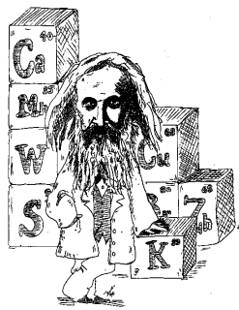
NOTES 2.2: The Periodic Table of Elements

Mendeleev

In ________, Dimitri Mendeleev found patterns in the _____________ and organized them into a __________.

Mendeleev grouped elements with similar _____________.

The resulting table had ______ left for elements not yet _____________.

The Periodic Table

Label the parts of the box for Titanium above.
Atomic Mass:

Atomic Number:

Ion Charge:

Metals, Non-metals, and Metalloids
Complete this chart:
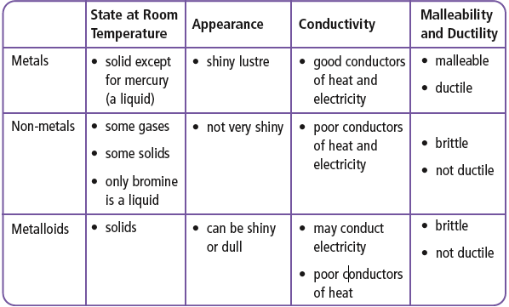
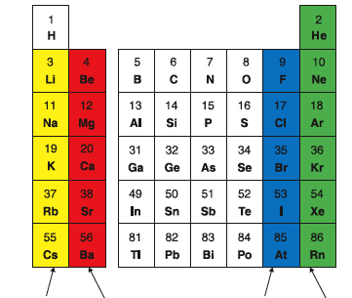
Periods and Families

On a Periodic Table,

Each horizontal row is called a _______________.

Vertical columns are called ________________.

Alkali Metals:

Alkaline Earth Metals:

Halogens:

Noble gases:

Please fill in the blanks for the definitions above. Also don’t forget to label the chart on the right.

Read pg. 52 – 63
Do the Reading Check on pg. 57 and answer the questions here:

Complete Textbook Pg 63 #4-21

