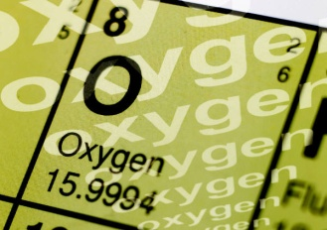
NOTES 2.1: Elements

Pure Substances

Chemical Symbols
There are 118 elements. Of these, around 92 occur naturally. The symbols for most elements are derived from Latin or Greek words. (See Table 2.1, p. 44 in Text)

- Symbols for all elements have only one or two letters.

- The First letter is ALWAYS

- The Second letter is ALWAYS

Characteristics of Groups of Elements
Refer to the tables and information on page 55 to list the properties of metals, non-metals and metalloids.
What does malleable mean? ________________________________________________________________
What does ductile mean? __________________________________________________________________
- Metals
  - _____________________________ (describe appearance)
  - _____________________________ (can be stretched into wire)
  - _____________________________ (can be beaten into sheets)
  - _____________________________ (transfer heat/electricity)
  - _____________________________ (state at room temperature: solid/liquid/gas)
  - Example metals: _________________, _________________, _________________
- Non-Metals
  - _____________________________ (describe appearance)
  - _____________________________ (can be stretched into wire)
  - _____________________________ (can be beaten into sheets)
  - _____________________________ (transfer heat/electricity)
  - _____________________________ (state at room temperature: solid/liquid/gas)
  - Example non-metals: _________________, _________________, _________________
- Metalloids
  - Possess properties of both ____________________ and ____________________.
  - Example metalloids: _________________, _________________, _________________
Pair up and select 3 elements to observe from the elements tray. Return when complete.
Element Name | Symbol | State  (solid/liquid/gas) | Colour | Shiny or Dull?  (shiny/dull) | Malleable?  (Y/N) | Ductile?  (Y/N) | Metal or Non-metal?  (m/nm)
Platinum | Pt | solid | silver | shiny | Y | Y | m

Scavenger Hunt

- I am found in all computers and I am the second most common element in the Earth’s crust:

- I am one of the most common elements in the universe. I am found in all stars, including the Sun:

- Although I can be used to make large ships, I will rust when exposed to water and oxygen:

- I am the only metal that is liquid at room temperature. Don’t play with me though as I am toxic:

- I am found in swimming pools and tap water. In gas form, I can be used as a weapon:

- I am so soft I can be cut with a knife. Don’t get me anywhere near water as I will explode:

- I am produced by plants and can be found in water. Life wouldn’t be the same without me:

DO THIS!
- Complete Textbook Pg 51 # 3-14, 18

