NOTES 1.1: Observing Living Things
- There are 5 characteristics of living things:
  - Living things _____________________________________
  - Living things ________________________
  - Living things _______________
  - Living things_________________
  - Living things ______________________________________
- Is a burning candle alive? Compare a burning candle to a human being: describe the similarities and differences. Explain
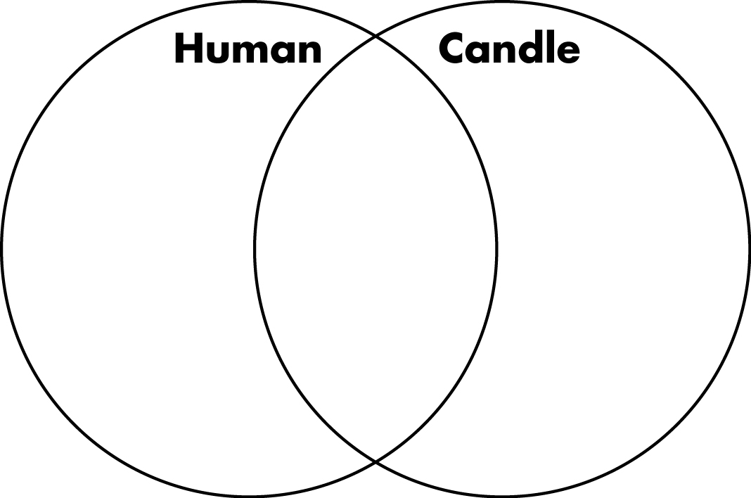
- Anton van Leeuwenhoek was one of the first people to build a _____________. He could magnify up to _______, and used it to observe microscopic living things.
- The compound light microscope has two sets of ___________ that magnify an image
- The ___________ lens has a total magnification of ______________
- Each of the objective lenses has a different magnification power.
  - Low power = ________ objective
  - Med power = ________ objective
  - High power = ________ objective
- Multiply the objective by the eyepiece for total magnification.
  - Example: High Power =
Now you try: Example. What would be the total magnification when viewing a specimen under medium power? Show your work

- The ability to distinguish between two dots or objects that are very close together is called __________________
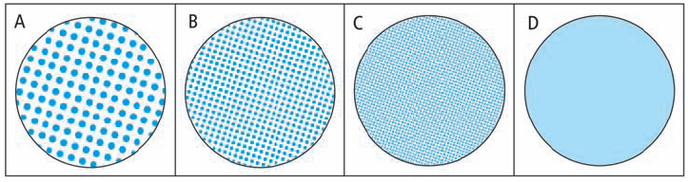
The human eye has a resolving power of ______________
The resolving power of a compound light microscope is ___________ (microns). A micron is a millionth of a meter
- The ______________________ is what you see when you look through the microscope.
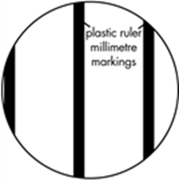
- Once you know the size of the field of view you can estimate the size of an object that you are viewing
- The diameter of the field of view represented on the left is ____________.
- We often use microns since most objects are smaller than a millimeter
- Multiply millimeters by ________________ to convert to microns
- Example. 2.5mm x _________ = ______________

Label the following parts of a compound light microscope.

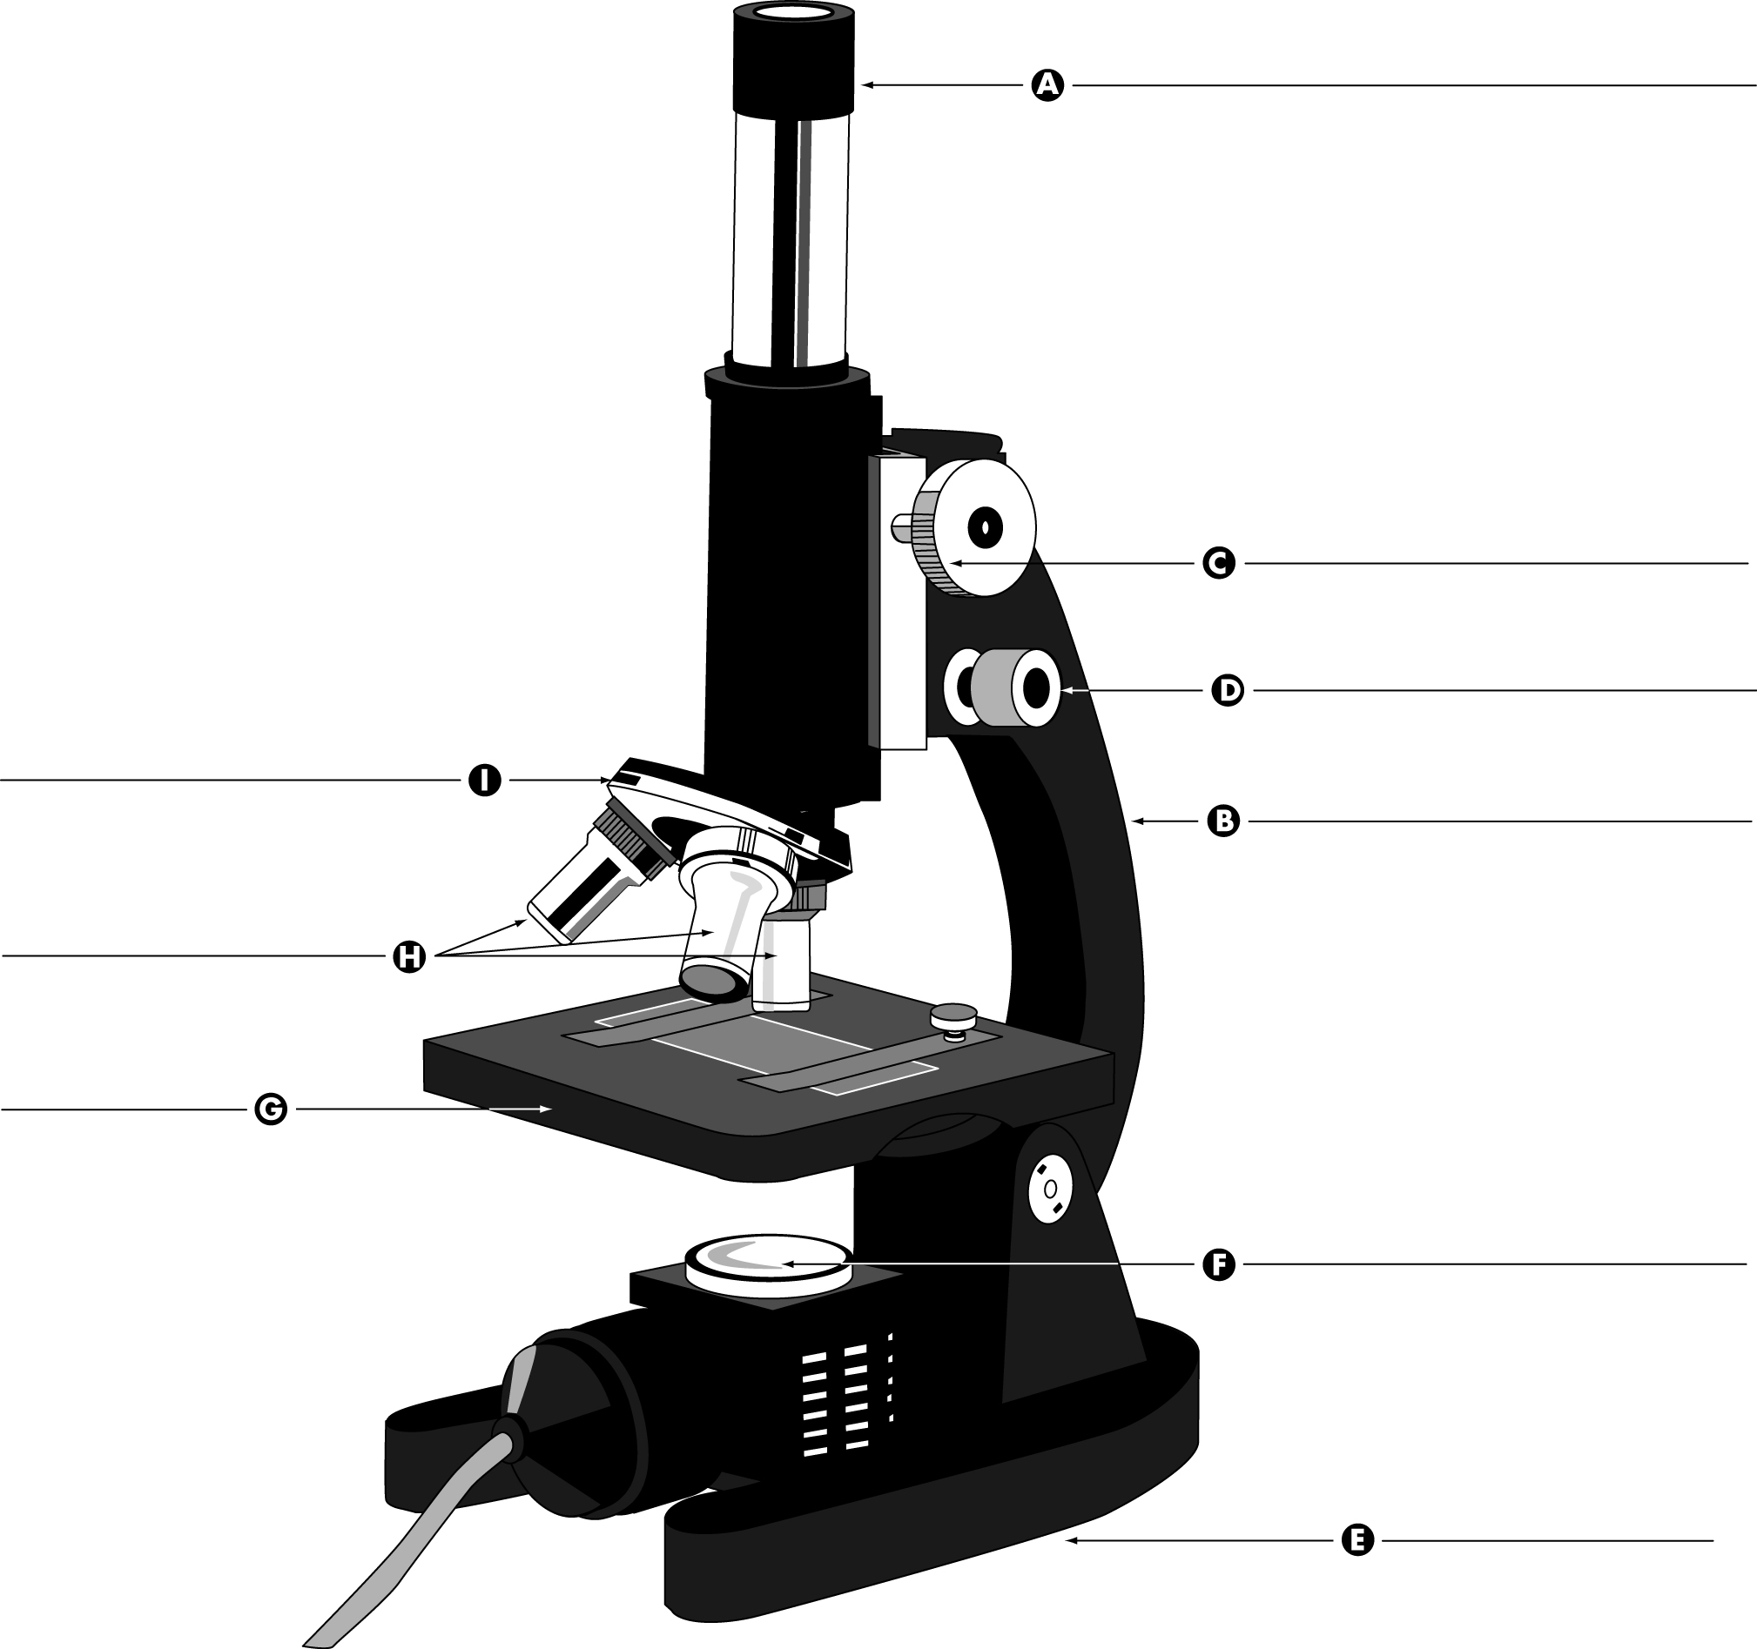

Each part of the compound light microscope is listed in the left column of the table below. In the right column, describe the function of each microscope part. For assistance, refer to pages 12–13 of BC Science 8.

Microscope part | Function
Eyepiece
Arm
Revolving nosepiece
Objective lenses
Fine focus knob
Coarse focus knob
Stage
Base
Light source

