Wave on a String Simulation

1. Access the Physics Education Technology website at the University of Colorado - Boulder by typing in "http://phet.colorado.edu/new/simulations/index.php" or by googling "PhET Simulations".

2. Under Simulations, click on Sound and Waves. Click on Wave on a String. Click on Run Now!

Part 1 – Explore the simulation

Take 5 minutes to just play with the simulation. Change some of the settings and see what happens

Part 2 – Examining a pulse wave

Set up the controls as shown below.
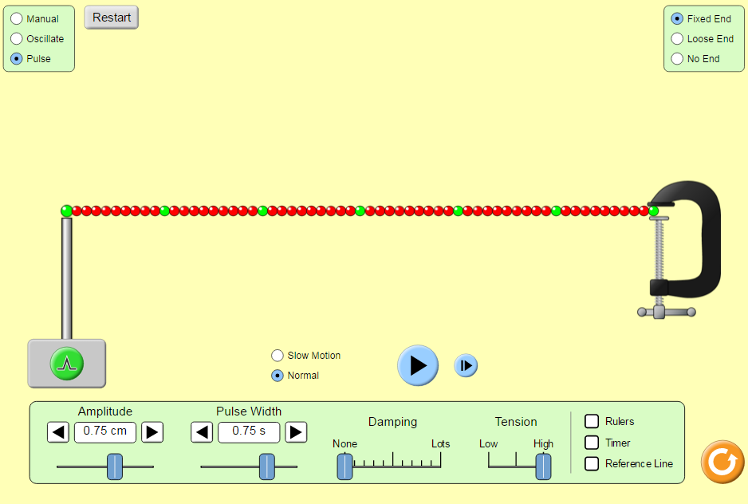
- Click on green pulse button. Observe the green beads.
Which direction does the wave move? __________
Which direction does the green bead move? ____________
What happens to the green bead once the wave has passed by?_____________________________________________

b.Move the slider that says “Damping” to until it is 2 small bars from the beginning. Describe what happened. What do you think is meant by the word “damping” in this case?
____________________________________________________________________________________________________________________________________________________________________________________________________________________________________________________

Part 2 – Amplitude

- For the first set of investigations, we will look at amplitude.
  - you need to be on
  - The rest of your screen should be set up like this:
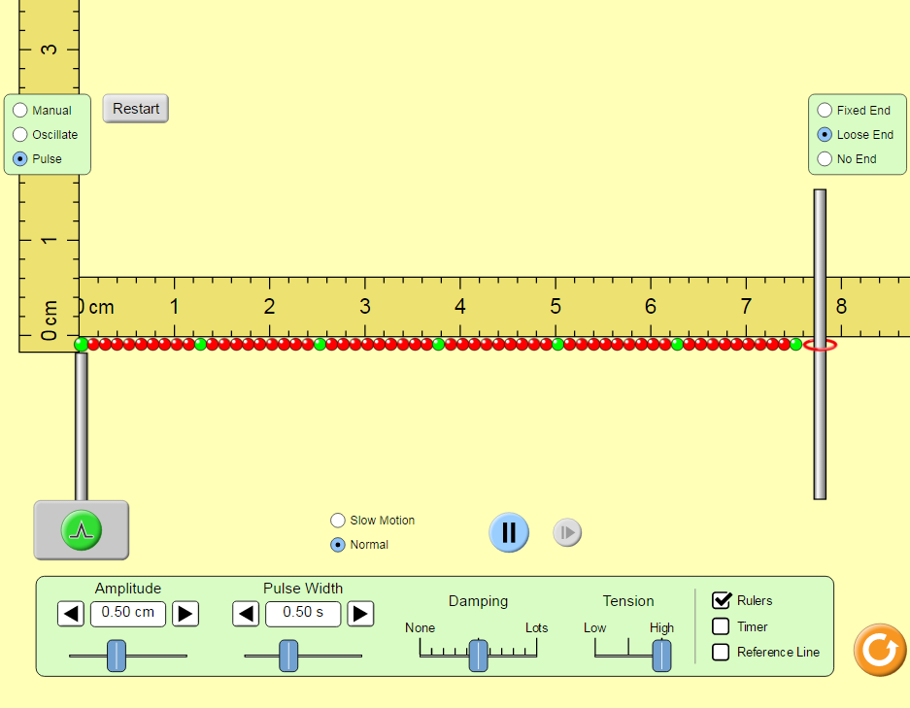

Amplitude setting | Height of wave at the start  (be sure your ruler is lined up correctly) | Distance ring moves on pole (end, use reference line to measure)
1.00 cm
0.75 cm
0.50 cm

The amplitude of a wave is related to the energy of a wave. Do you think that a wave with high amplitude has a lot of energy or a little bit of energy? Why do you think this? Did you see anything on the screen that made you think this or could prove your point? How could you demonstrate this relationship?
__________________________________________________________________________________________________________________________________________________________________________________________________________________________________________________________________________________________________________________________________________________________________________________________________________________________________________________________________________________________________________________________________________________________________________________________________________________________________________________________________________________________

Part 3 – Wavelength

- For this next part we will investigate wavelength.
  - You need to be on
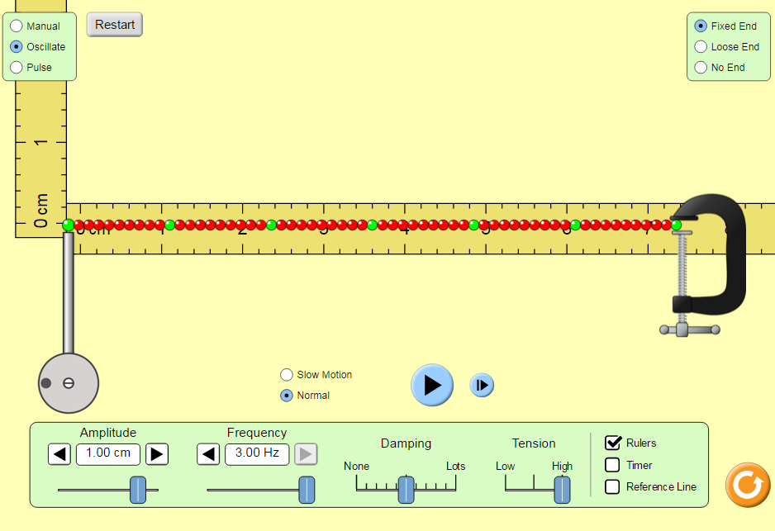
  - The rest of your screen should be set up like this
  - Try out the button after you hit pause. This may be useful for collecting data.
Data:
Wavelength = _______ cm

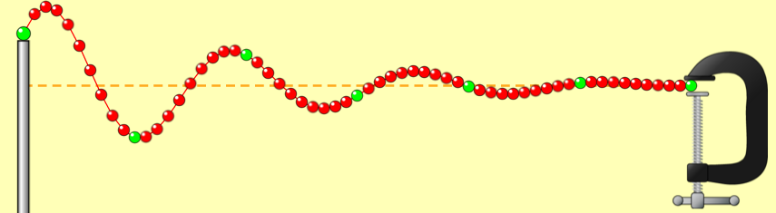
Wavelength = _____ cm
Discuss how they were similar and how they were different.
______________________________________________________________________________________________________________________________________________________________________________________________________
Part 3 - Frequency

For the next set of investigations, we will look at frequency.
  - Your screen should be set up like we did for part 3 (make sure timer is on)
  - Remember, to stop or slow the wave use pause/play and .
- Look over the data table and discuss how you will collect the data you need.
- Before you begin… try a little practice using the timer:
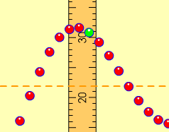
- Turn the timer on, off and reset the timer while waves are moving.
- Practice counting waves passing a given point:
- Move the vertical ruler so that it is along the wave’s path. This will be the point where you watch waves pass and count them. Count 5 waves passing the ruler. Change the frequency and count again.
- Fill in the table by working together counting the waves and using the timer.
Data:
frequency | Time interval | Number of waves: |  |  | Average number of waves counted in 10 second period | Number of waves in 1 second  _{frequency**}
 |  | Trial #1 | Trial #2 | Trial #3
0.50 Hz | 10 seconds
1.00 Hz | 10 seconds
3.00 Hz | 10 seconds
*To find frequency, divide the average number of waves counted by the time interval.

5. Talk about the data.

- Decide on a way your group can explain wave frequency to the class.
- Write your idea(s) on the lines.

__________________________________________________________________
__________________________________________________________________
__________________________________________________________________

Part 4 – The relationship between frequency, wavelength and amplitude

- Now let’s look at wavelength. Move the amplitude to 0.50 cm, frequency to 1.50 Hz, and damping to 0. Choose the option that says “No end” and create a wave. Pay careful attention to the wavelength of the waves that are created. Click the pause button and choose the ruler from the top bar. Measure the wavelength of the wave that has been created. Remember that wavelength is from one point to the exact same point of the next wave.
Wavelength = _______________________________
- Now press play. Increase the frequency of the wave to 2.00 Hz and measure the wavelength, then reduce the frequency to 1.00 Hz and measure the wavelength. How does increasing the frequency affect the wavelength of the wave?
___________________________________________________________________________________________________________________________________________________________________________________________________________________________________________________________________________________________________
- Move the frequency of the wave back to 1.50 Hz. Now change the amplitude of the wave to 0.75 cm and measure the wavelength and to 0.25 cm and measure the wavelength. What affect did you notice? __________________________________________________________________________________________________________________________________________________________________________________________________
What are the relationships that are present between frequency, wavelength, and amplitude of a wave?
___________________________________________________________________________________________________________________________________________________________________________________________________________________________________________________________________________________________________________________________

Finish the following statements:
- If the frequency of a wave is doubled, the wavelength will be ________________________.
- If the wavelength of a wave is doubled, the frequency of the wave will be______________.

Follow up questions

- Use a pencil to draw a wave over the following one to show what would happen if the amplitude was increased:
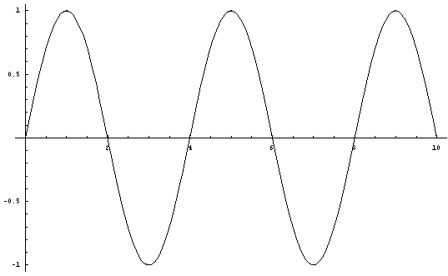

Line of --origin------
- Use a pencil to draw a wave over the following one to show what would happen if the frequency was increased:

Line of --origin------

