**Unit 5**

**Two-Variable Linear Relations**

Objectives:

* to represent pictorial, oral, and written patterns using linear expressions, equations and graphs
* to interpret patterns on graphs
* to solve problems involving pictorial, oral and written patterns by using linear equations and graphs

**Lesson 1 – Representing Patterns (6.1)**

*A linear relation ________________________________________________________*

*______________________________________________________________________*

1. a) Draw the next two figures in this series.

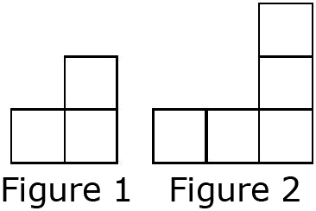

b) Create a table of values comparing the number of squares and the figure number.

|  |  |
| --- | --- |
| Figure Number, *n* | Number of Squares, *s* |
|  |  |
|  |  |
|  |  |
|  |  |

c) Describe the pattern.

d) Write the equation that represents this pattern.

e) How many squares are in Figure 15?

f) Which figure number has 69 squares?

|  |  |  |  |  |  |
| --- | --- | --- | --- | --- | --- |
| a) | *d* | 0 | 1 | 2 | 3 |
|  | *t* | 11 | 16 | 21 | 26 |

|  |  |  |  |  |  |
| --- | --- | --- | --- | --- | --- |
| b) | *c* | 1 | 2 | 3 | 4 |
|  | *r* | –2.1 | –0.6 | 0.9 | 2.4 |

**2.** What linear equation models the relationship between the values in each table?

3. A number pattern starts at 1.5. Each number after that is four more than the number before.

a) Make a table of values for the first five terms.

|  |  |
| --- | --- |
| Term Number, *t* | Number, *n* |
|  |  |
|  |  |
|  |  |
|  |  |

b) Develop an equation that can be used to determine the value of each term in the pattern.

c) What is the value of the 95th term?

d) Which term has a value of 237.5?

**4.** On top of the $45 monthly fee, Sam’s cell phone plan charges $0.15 for every text message he sends or receives.

a) Develop an equation to calculate the monthly bill.

b) What would Sam’s bill be if there were 20 text messages in a month?

c) If Sam budgets $80 a month for his cell phone, how many text messages can he send or receive each month? Explain.

*Homework:*

Lesson 2 – Interpreting Graphs (6.2)

Interpolate-______________________________________________________

Extrapolate-______________________________________________________

1. a) What is the approximate value of *d* when *t =* 3? ______

Explain the method you used.

________________________

________________________

________________________

b) What is the approximate value of *t* when *d* = 300? ______

2. a) What is the approximate value of *y* when *x* = –1.5? ____

b) What is the approximate value of *x* when *y* = 10? ____

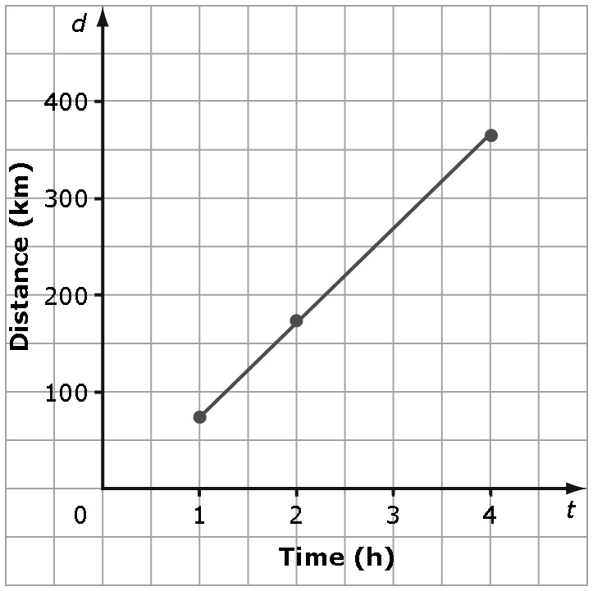

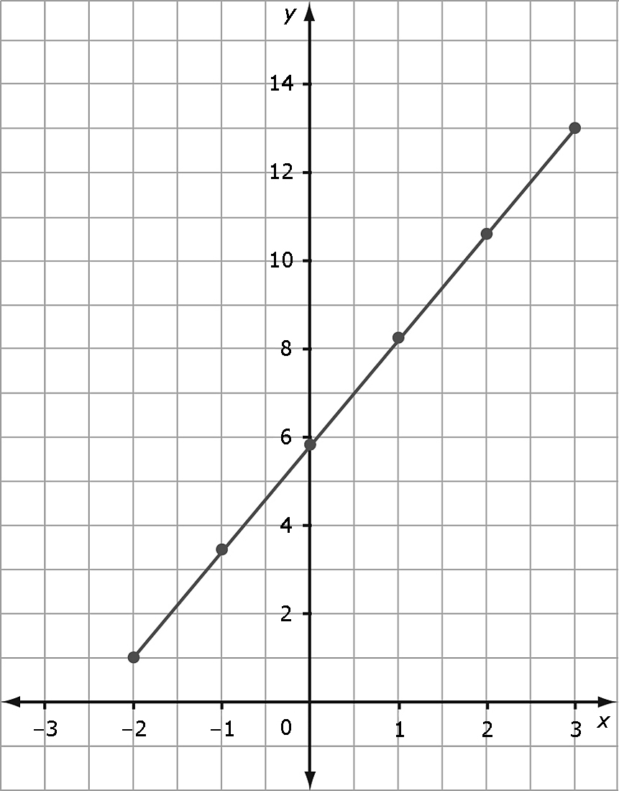

3. a) What is the approximate value of *y* when *x* = 3.5? ____

b) What is the approximate value of *x* when *y* = 0.5? ____

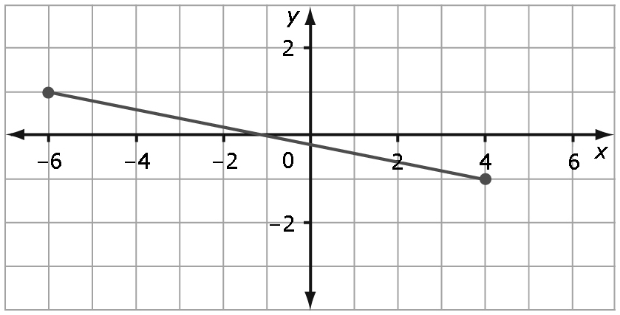

4. a) In the deli section of a grocery store, Greek salad costs $1.50 per 100 g. Plot the data on a graph.

|  |  |  |  |  |  |
| --- | --- | --- | --- | --- | --- |
| Mass of Greek Salad, *m* (g) | 100 | 200 | 300 | 400 | 500 |
| Cost, *C* ($) | 1.50 | 3.00 | 4.50 | 6.00 | 7.50 |



b) From the graph, determine the cost of 800 g of Greek salad. ______

c) From the graph, determine how much salad you get for $10.50. ______

5. A car rental company charges a flat rate of $35.00 plus $0.45 per kilometre for renting a car. The graph shows the cost of renting a car based on the number of kilometres driven.

a) Is it reasonable to interpolate or extrapolate values on this graph? YES NO Explain.

___________________________

___________________________

___________________________

b) What is the rental cost after driving 300 km? ________

*Homework:*

*Quiz: 6.1/6.2:___________________*

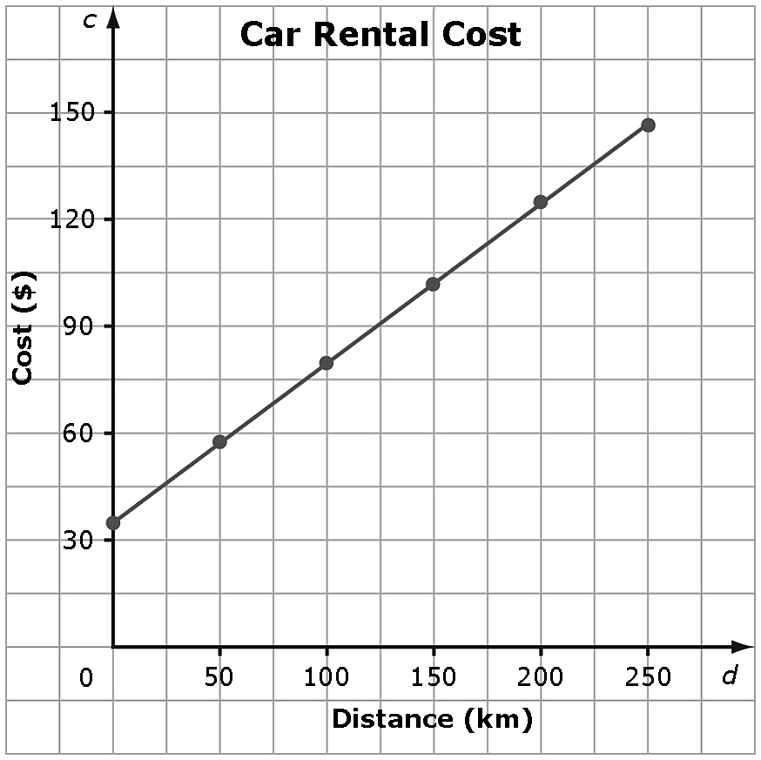

c) Approximately how many kilometres can be driven for a rental cost of $115? ______.

Lesson 3 -Graphing Linear Relations (6.3)

1. Suri drives at an average speed of 90 km/h. The equation relating distance, *d*, and time, *t*, is *d* = 90*t*.

a) Complete a table of values to represent the relation.

|  |  |
| --- | --- |
| Time, *t* | Distance, *d* |
|  |  |
|  |  |
|  |  |
|  |  |
|  |  |
|  |  |

b) Show the relationship on a graph.



c) How long does it take Suri to drive 630 km?

2. For each linear equation, create a table of values and a graph

|  |  |  |  |  |  |  |  |  |  |  |  |  |  |  |  |  |  |
| --- | --- | --- | --- | --- | --- | --- | --- | --- | --- | --- | --- | --- | --- | --- | --- | --- | --- |
| |  |  | | --- | --- | | ***x*** | ***y*** | | –3 |  | | –2 |  | | –1 |  | | 0 |  | | 1 |  | | 2 |  | | 3 |  |   a) | http://etc.usf.edu/clipart/49300/49300/49300_graph_1010b_lg.gif |
| |  |  | | --- | --- | | ***s*** | ***t*** | | –3 |  | | –2 |  | | –1 |  | | 0 |  | | 1 |  | | 2 |  | | 3 |  |   b) | http://etc.usf.edu/clipart/49300/49310/49310_graph_blank_lg.gif |
| |  |  | | --- | --- | | ***f*** | ***g*** | | –3 |  | | –2 |  | | –1 |  | | 0 |  | | 1 |  | | 2 |  | | 3 |  |   c) | http://etc.usf.edu/clipart/49300/49310/49310_graph_blank_lg.gif |

**3.** Create a graph and a linear equation to represent each table of values.

|  |  |  |  |  |  |  |  |  |  |  |  |  |  |  |  |  |  |  |  |  |  |  |  |  |  |
| --- | --- | --- | --- | --- | --- | --- | --- | --- | --- | --- | --- | --- | --- | --- | --- | --- | --- | --- | --- | --- | --- | --- | --- | --- | --- |
| |  |  |  | | --- | --- | --- | | **a)** | ***x*** | ***y*** | |  | –3 | 4 | |  | –2 | 4 | |  | –1 | 4 | |  | 0 | 4 | |  | 1 | 4 | |  | 2 | 4 | |  | 3 | 4 | | http://etc.usf.edu/clipart/49300/49310/49310_graph_blank_lg.gif |
| |  |  |  | | --- | --- | --- | | **b)** | ***a*** | ***g*** | |  | 5 | 4 | |  | 6 | 4.5 | |  | 7 | 5 | |  | 8 | 5.5 | |  | 9 | 6 | |  | 10 | 6.5 | | http://etc.usf.edu/clipart/49300/49300/49300_graph_1010b_lg.gif |
| |  |  |  | | --- | --- | --- | | c) | *t* | *d* | |  | 0 | –2.0 | |  | 1 | –1.75 | |  | 2 | –1.5 | |  | 3 | –1.25 | |  | 4 | –1 | |  | 5 | –0.75 | | http://etc.usf.edu/clipart/49300/49310/49310_graph_blank_lg.gif |

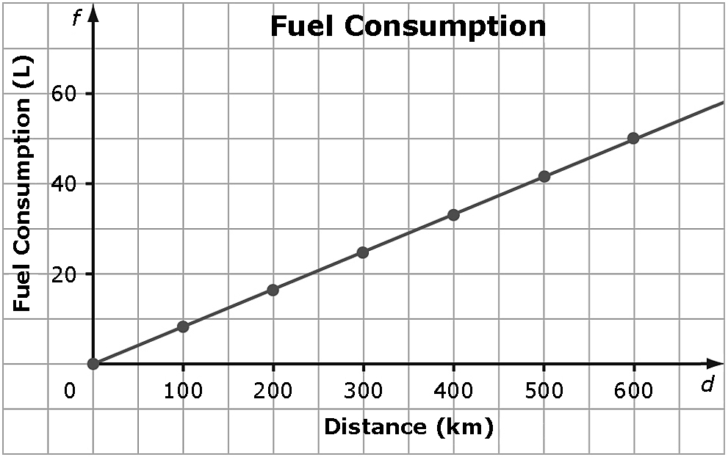4. The graph shows the relationship   
between the fuel consumption, *f*,   
in litres (L), and the distance driven,  
*d*, in kilometres (km).

1. What is the linear equation?
2. How far could you drive with 34 L of gas?

c) Is it appropriate to interpolate or extrapolate values on this graph? What assumption is being made? Explain.

*Homework: Complete 6.3 Practice Handout;*

*Review Handout*

*Test:______________________*