Math 11 AWP Unit 5 – Slope and Rates of Change
Assignment 5 – Slope and Rate of Change
- The line on a graph has the following points. Calculate the slope of the line.
- (0, 0) and (4, 204) b. (12, 3) and (16, 4.5)

- (150, 3) and (25, 6)

- Use the graph to draw the following
- Draw a solid line on the graph that passes through point (0, 0) and has a slope of 5/4.
- Draw a dotted line on the graph that passes through point (2, 1) and has a slope of 2/3
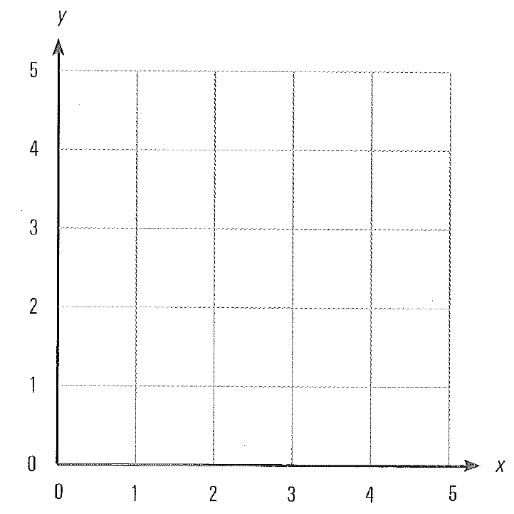
- Henrik earns $64.80 in 6 hours at his weekend job. Javier earns $56.25 in 5 hours.
- Calculate their earnings for five different lengths of time.

- On the same graph, draw a solid line indicating Henrik’s earnings and a dotted line showing Javier’s earnings.
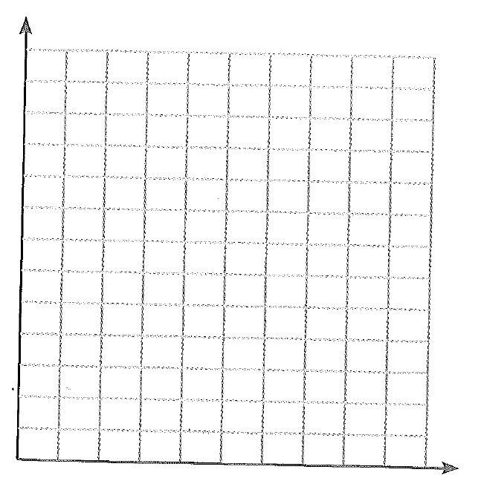
- Janice is a real estate agent. When she makes a sale, she earns a commission of 4% of the value of the house. She earned $7560.00 on the sale of a house. What was the selling price?

- Rita is participating in a cycling trip. After 2 hours and 15 minutes of cycling, she takes a rest. She has travelled 40 km. She then continues cycling and stops at a location 75 km from her starting point. She has cycled a total of 4 hours.
- What was her average rate of travel between the 40 km stop and the 75 km stop?

- If she continues at the same rate, how far will she have travelled after 6 hours of cycling in total?

- Sheila and Brandy are on a backpacking trip.
- If Sheila walked 28.8 km in 6 hours and Brandy walked 32.2 km in 7 hours, who is the faster walker?

- Graph their walking rates on the same graph.
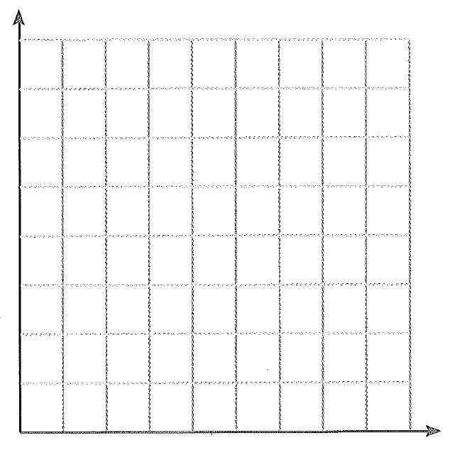
- How long does it take each of them to walk 10 km?

- Water flows from a tank at a rate of 1500 litres per minute. The tank has a volume of 480 000 L.
- Fill in the following table showing how much water is left in 30 minute intervals.
Time elapsed (minutes) | Volume of water remaining (L)
0
30
60
90
120
150
- Draw a graph of the date.
- Calculate the slope. What does it represent?

- When will the tank be empty?

