Math 11 AWP Unit 5 – Slope and Rates of Change
Assignment 3 – Grade and Pitch
- Heckman Pass is a very steep section of highway connecting Anahim Lake and Bella Coola, B.C. At its steepest section, it rises 900 m over a run of 5 km. What is the percent grade of this section?

- So that water will drain properly, a patio attached to a house should slope downward about 2 ½ inches for every 10 feet of run. Calculate:
- The slope; and

- The percent grade.

- One of the steepest railways in the world is the Lisbon tram in Portugal. In one section, it has a grade of 13.5%.
- Express this as a slope.

- What is the ride for a run of 15 m?

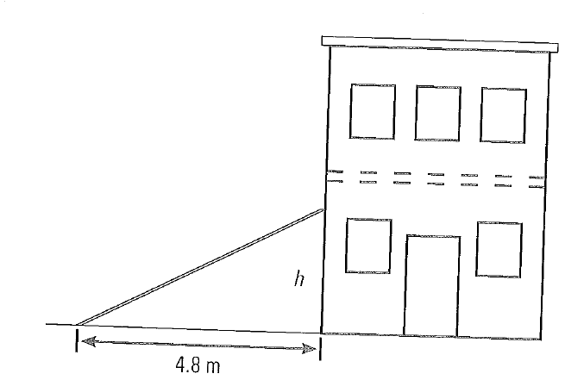
- The pitch of roof on a lean-to that Dianna is building is 2:5. If the lean touches the ground 4.8 m from the base of the building, how high up the building does it reach?

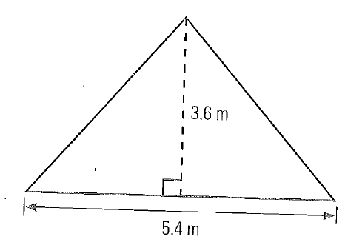
- What is the pitch of the roof of an A-frame building if its height is 3.6 m and its width is 5.4 m?

- The roof of a tool shed has a pitch of 2:5. If the shed is 7 feet wide, what is the rise of the roof?

