Math 11 AWP Unit 5 – Slope and Rates of Change
Assignment 2 – Slope
- Calculate the slope as a fraction in the simplest form and as a decimal.
Rise | Run | Slope
 |  | As a fraction ($m=\frac{rise}{run}$) | As a decimal
18 m | 63 m
21 m | 49 m
1.2 cm | 0.6 cm
12.4 mm | 4.6 mm
300 ft | 900 ft
- Use the information given to complete the table.
Rise | Run | Slope
15 ft |  | $$\frac{1}{4}$$
12 cm |  | 0.375
 | 16 m | $$\frac{9}{5}$$
 | 42 in | $$\frac{32}{7}$$
63 m |  | 3.0
19.5 ft |  | 0.25
- Zane is designing a small waterslide for children to play on. If the slide has a run of 120 inches and a height of 56 inches, what is the slope of the slide?

- A safe slope for a ladder is 1 ft of run for every 4 ft of rise. Vincent needs to use a ladder to reach a window sill that is 22 ft above the ground. How far from the house should the base of the ladder be?

- Harj is digging a drainage ditch. It must drop 3 cm for every 1.5 m of horizontal distance. How much will it drop in a horizontal distance of 25 m?

- The slope of a hill is an average of 0.64. How many metres will it rise for a horizontal distance of 32 metres?

- Hazuki needs to calculate the slope of the water table – the elevation at which water is found underground. One well has water at 752 m elevation and the other has it 895 m elevation. If the wells are 1.2 km apart, what is the slope of the water table?

- Calculate the slope of the roof and the diagonal trusses.
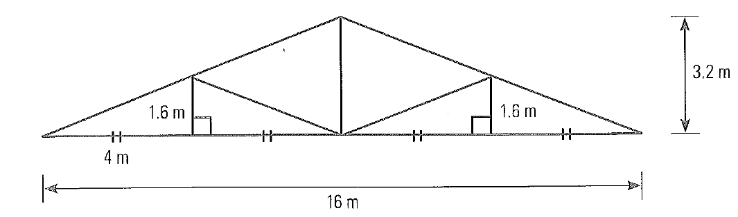

- Alfred wants to make a doll house that is a copy of his own house. The roof of his house is 10.8 m wide and is 2.4 m higher at the centre than the edges. If the doll house is 1.6 m wide, what will be the rise of the roof?

