Math 11 AWP Unit 1 – Graphical Representation
Assignment 5 – Double Bar Graphs
- The following table shows average weekly household expenses of all Canadian households with children compared to the expenses of households in the lowest income range in the country
AVERAGE WEEKLY HOUSEHOLD EXPENSES, CANADA
Item | Food and drink | Clothing | Heat and electricity | Health | Transportation | Communication | Rec and culture | Ed. | Eating out
Lowest Income households | 104 | 44 | 124 | 2 | 70 | 22 | 78 | 6 | 56
All households with children | 140 | 62 | 130 | 4 | 176 | 26 | 160 | 30 | 104
- Draw a double bar graph to represent the data.
- Explain the trends in spending of the lowest income families compared to all families.

- In order for citizens of other countries to travel to Canada, they may be required to get a visa, which is a document that shows the person is authorised to enter the country. Sally works at Citizenship and Immigration Canada, and has gathered information on the number of visas applied for and the number approved over the course of one year.
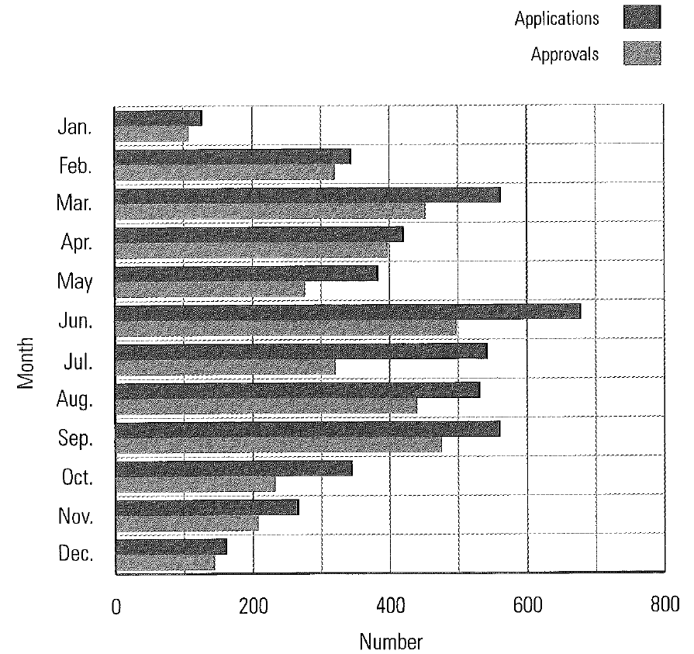
- In which month were the most applications for visas received? How many visa applications were received that month? In which month were the fewest applications received? How many were received that month?

- In which month was there the greatest difference between the number of applications and the number of approvals? What was the approximate difference?

- The following graph shows the high and low daily temperature for one week in November in Pincher Creek, Alberta.
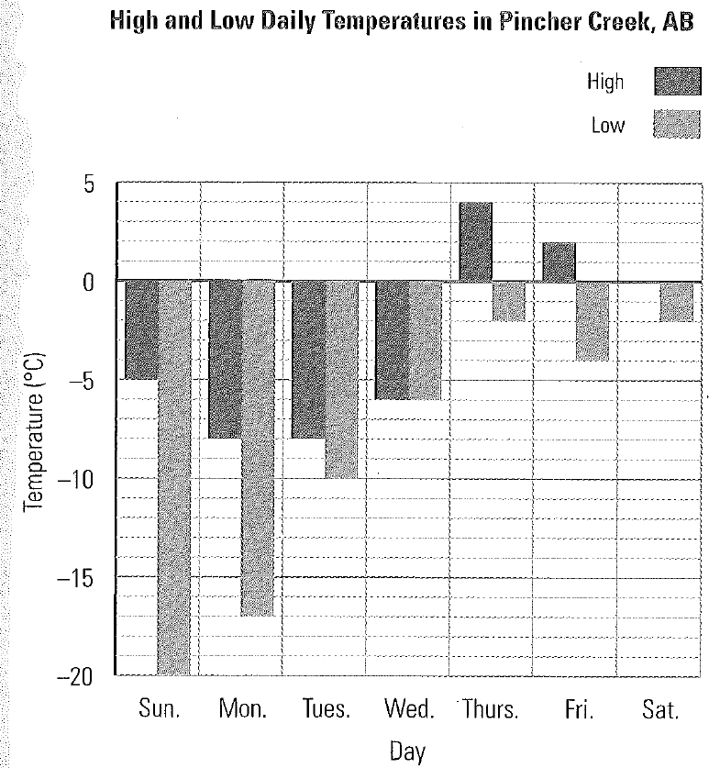
- Why are most of the bars going downward?

- Why is there no black bar on Saturday?

- What is significant about Wednesday’s temperature?

- What was the general trend in temperature during the week?

- Trina did a survey of her school to find out students’ favourite sports to watch on TV. The results are summarized below.
SURVEY RESULTS: FAVOURITE SPORT TO WATCH ON TV
Sport | Football | Hockey | Basketball | Baseball | Golf
Boys | 135 | 243 | 101 | 79 | 18
Girls | 121 | 285 | 75 | 15 | 2
- Draw a double vertical bar graph and a stacked vertical bar graph to represent the data.

- How many people took the survey?

- What is the most popular sport to watch on TV?

- What are the benefits of the double bar graph? What are the benefits of the stacked bar graph?

- Consider the three multiple bar graphs in questions #1, 2, and 3 above. Which of the three graphs is most suitable for a stacked bar graph? Explain your answer.

- Petro is a trainer at the local gym. He recorded the following information about the number of people who used the equipment who used the equipment during the day. Graph the data on a horizontal bar graph.
NUMBER OF USERS OF FITNESS EQUIPEMENT PER DAY
Equipment | Stationary bike | Treadmill | Elliptical cross-trainer | Stairclimber
Number | 142 | 167 | 85 | 149

- A multiplex theatre has eight different sized theatres. In order to determine which movie should be shown in which theatre, Mollie polled people on the street as to which movie they should attend. Her results are displayed in the graph below.
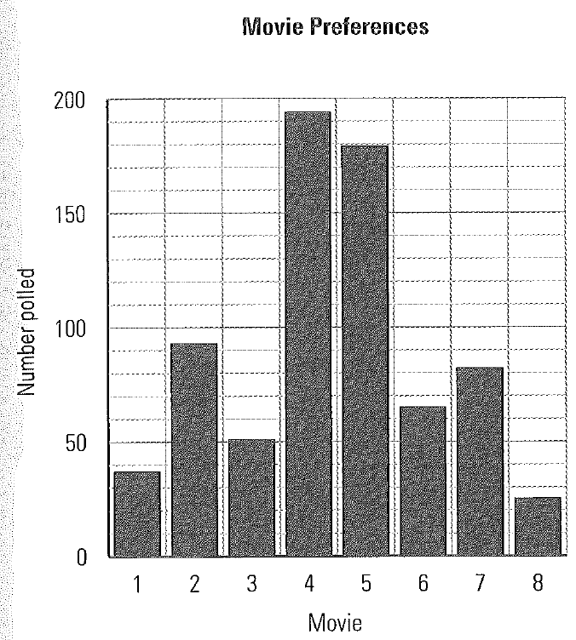
- Which are the two most popular movies?

- Which is least popular?

- Use the graph below to discuss the general trend of students taking home economics classes at high school in Brandon, MB, over a period of five years.
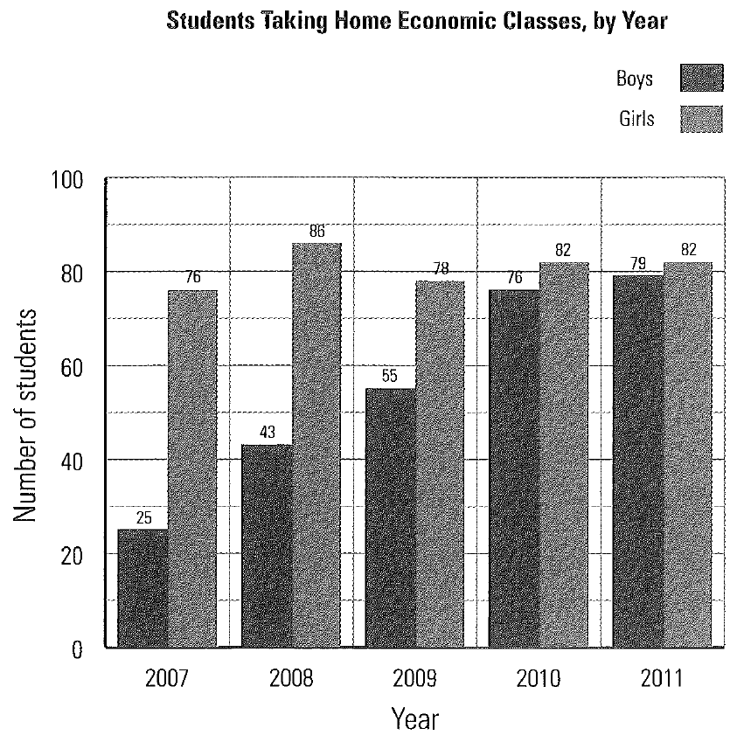

- A real estate agent wants to compare the number of single-detached house and multiple-unit construction projects started in Abbotsford, BC, over a period of five years.
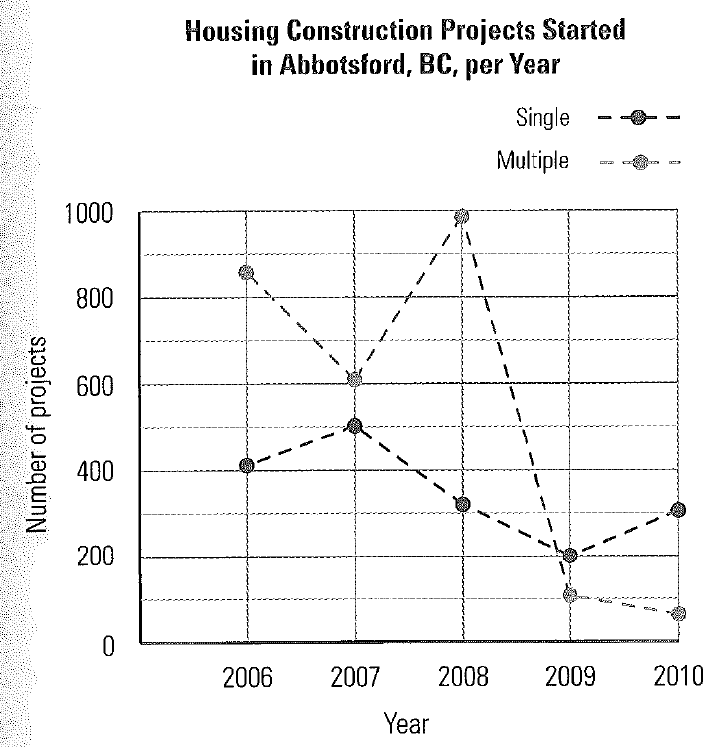
- Use the graph to explain trends in housing projects in Abbotsford.

- Use the data from the graph to draw a double bar graph comparing the number of housing projects. Which graph do you prefer for presenting the data? Why?

