Math 11 AWP Unit 1 – Graphical Representation
Assignment 2 – Interpolation and Extrapolation and Multiple Broken line Graphs
- Thérèse is on a road trip and is keeping track of her car’s fuel consumption. The graph below shows the amount of gas in Thérèse’s car at different times of the day. Use the graph to discuss what she may have been doing during the different time frames.
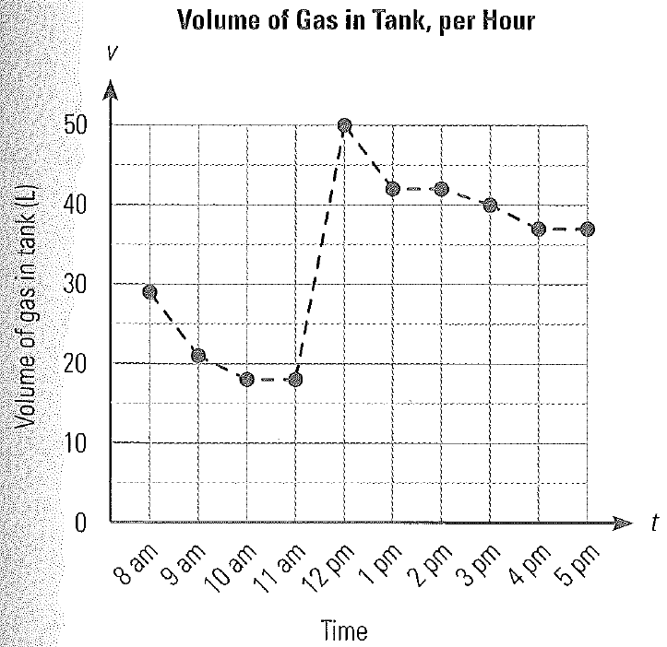

- Lumber is often priced in board feet. A board foot is a is a piece of lumber 1 foot long by 1 foot wide by 1 inch think. The graph below represents the cost per board foot of kiln-dried spruce over a period of one year.
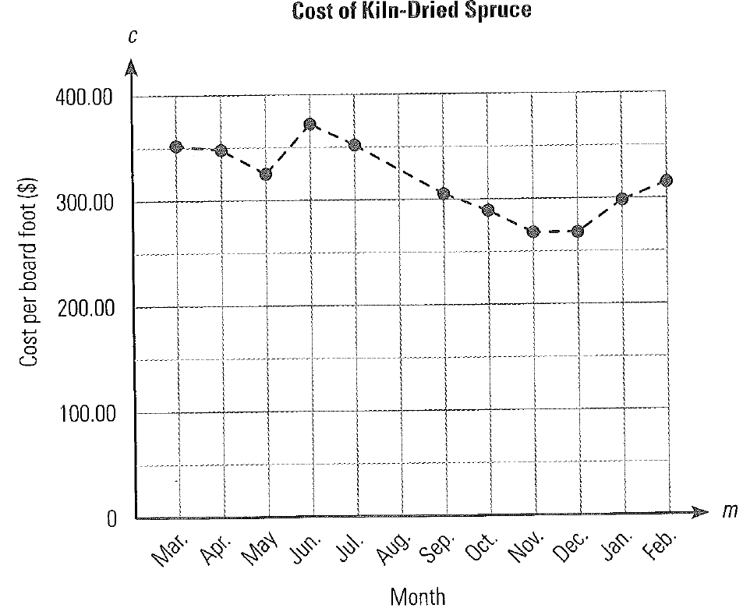
- What is the general trend in the cost of kiln-dried spruce?

- The graph does not show the cost in August. Use the graph to interpolate the cost of kiln-dried spruce that month.

- Based on the general trend in the data, what would you estimate the cost of kiln-dried spruce to be the following month, March?

- Raquel is an agent for a cell phone company. The data below indicated the number of cell phones sold to males and females in the last year.
Cell Phone Buyers by Gender
Month | Jan | Feb | Mar | Apr | May | Jun | Jul | Aug | Sep | Oct | Nov | Dec
Male | 53 | 150 | 75 | 238 | 105 | 167 | 102 | 309 | 298 | 76 | 153 | 398
Female | 21 | 222 | 89 | 174 | 309 | 111 | 76 | 398 | 442 | 123 | 67 | 299

- Use the data to draw a double broken line graph.
- Write a statement describing the general trend in cell phone purchases over the year.

- Does the graph indicate any relationship between the number of cell phones purchased by males compared to females? Why or why not?

- Do you think this graph is a useful representation of the data? If so, why? If not, what might be a better way to show the trends in cell phone purchases?

- At the end of every month, Suzanne keeps a record of the price of two stocks she bought.
Stock Price by Month
Month | Jun | Jul | Aug | Sep | Oct | Nov | Dec | Jan | Feb | Mar | Apr | May
Stock A | $2.75 | $2.95 | $1.43 | $0.89 | $0.76 | $0.98 | $1.14 | $1.28 | $0.65 | $0.45 | $0.76 | $0.53
Stock B | $1.25 | $1.11 | $1.32 | $1.45 | $1.20 | $1.25 | $1.87 | $1.59 | $1.76 | $1.43 | $1.38 | $1.21

- Draw a double broken line graph.
- Use the graph to discuss the trends in the price of the two stocks and how the prices of the two stocks compare.

- If Suzanne were to sell one and buy more of the other, which would you suggest she sell? Why?

