Series and Parallel CPU LAB

MARKING RUBRIC /15 marks

 | 0-1 | 2 | 3 | 4 | 5
Observations | - Most data is not represented or is not accurate  - Several tables not completed | - Accurate representation of the data in few tables – many errors | - Accurate representation of the data in most tables, but more than 1 error | - Accurate representation of the data in most tables except for 1 error  - All units given correctly | - Accurate and complete representation of the data in all tables  - All units given correctly  - Numbers rounded to nearest whole
Analysis | - Several questions are not answered  - Answers show little/no understanding of the key concepts demonstrated in the lab | - Answers to questions are incomplete  - Analysis is inconsistent and often incorrect | - Most questions are answered briefly  - Analysis is general with several errors | - Most questions are answered in complete sentences  - Analysis is mostly correct and thoughtful | - Questions are answered thoroughly and in complete sentences  - Analysis is insightful and correct
Conclusion  “0”  no conclusion included | - The conclusion shows little effort and reflection on the lab. An understanding of the lab has not been demonstrated. | - A statement of the results is incomplete with little reflection on the lab. Conclusion is inconsistent. | - A statement of the results of the lab indicates a satisfactory understanding of the topic. Few or no observations from lab not used in the analysis. | - Accurate statement of the results of the lab indicates a good understanding of the topic. Some observations from the lab were used in the analysis. | - Accurate statement of the results of the lab indicates a very good understanding of the topic. Specific observations and examples from the lab procedure were used throughout the analysis.

Series and Parallel Online LAB

In this activity, you will be using an electric circuit program to study the ideas of series and parallel in an electric circuit. Website: phet.colorado.edu/en/simulation/circuit-construction-kit-dc

PURPOSE:
- To construct a series and a parallel circuit
- To correctly place a voltmeter and ammeter into a circuit
- To measure the current and voltage in a circuit
- To develop a relationship between the voltage and current in a circuit

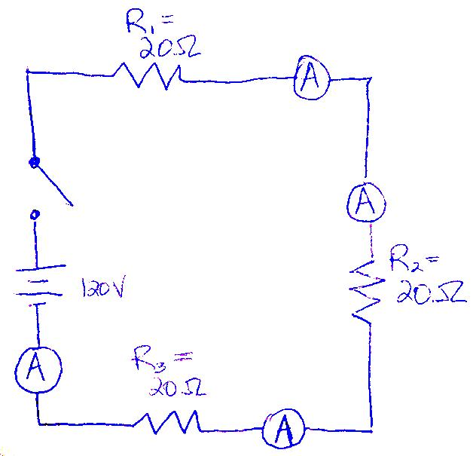
Data Collection and Analysis: Series Circuits
1. Open the circuits program.

2. Construct a series circuit (as shown here) containing:
• 120 v battery (use two 60 V batteries)
• three 20 Ω resistors connected in series to the battery
• a switch to control the current leaving the battery
• meters (anmeters and a voltmeter) to measure the voltage and current through each resistor and the battery.

3. Close the switch and turn on the circuit. Record your measurements of the voltage and current in each device in the table below.

 | Voltage (V) | Current (A)
Battery (total)
Resistor #1 (20 Ω)
Resistor #2 (20 Ω)
Resistor #3 (20 Ω)

3a. How do the currents through each resistor in the series circuit compare with each other and the current from the battery? _______________________________________________________________________
_____________________________________________________________________________________
3b. Calculate the total voltages lost across all resistors added in the circuit.
V _{Total} = V₁ + V₂+ V₃=____ +_____+ ____=_______

3c. What is the total voltage provided by the battery in the circuit: ______________________________

3d. What do you observe about the TOTAL voltages lost and voltage provided by the battery in a series
circuit?__________________________________________________________________________

4. Change the values of the resistors to 20Ω, 40Ω and 60Ω. Close the switch and turn on the circuit. Record your measurements of the voltage and current in each device in the table below.

 | Voltage (V) | Current (A)
Battery (total)
Resistor #1 (20 Ω)
Resistor #2 (40 Ω)
Resistor #3 (60 Ω)

5a. How do currents compare through each resistor in series?

_____________________________________________________________________________________

5b. What do you observe about the TOTAL voltages lost and voltage provided in this series circuit?
______________________________________________________________________________________
______________________________________________________________________________________
5.c. How does increasing the resistance of resistors in series affect the voltage lost across each resistor?
______________________________________________________________________________________

______________________________________________________________________________________
5.d. How does increasing the overall resistance in the series circuit affect the current? Compare both tables of data completed for the series circuits. _____________________________________________________
_____________________________________________________________________________________

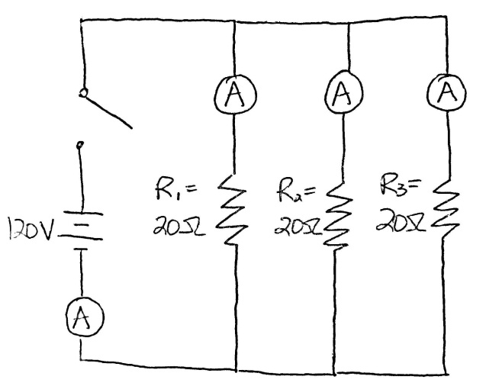
Data Collection and Analysis: Parallel Circuits

1. Construct a parallel circuit (as shown here) containing:
• 120 v battery
• three 20 Ω resistors, each connected in parallel to each other
• a switch to control the current leaving the battery
• meters to measure the voltage and current on the battery and each resistor

2. Close the switch and turn on the circuit. Record your measurements of the voltage and current in each device in the table on the next page.
Parallel Circuit:

 | Voltage (V) | Current (A)
Battery (total)
Resistor #1 (20 Ω)
Resistor #2 (20 Ω)
Resistor #3 (20 Ω)

2a. What do you notice about the currents in each branch of the resistors connected in parallel compared to the total current through the battery? ____________________________________________________

_____________________________________________________________________________________

_____________________________________________________________________________________

2b. Refer to table above. Why are the currents through each branch of the parallel circuit the same value?
_____________________________________________________________________________________

2c. How do the voltages lost across each resistor in the parallel circuit compare to the total voltage provided by the battery?______________________________________________________________

_____________________________________________________________________________________
3. Change the values of the resistors to 10Ω, 20Ω and 30Ω. Record your measurements of the voltage and current in each device in the table below.

 | Voltage (V) | Current (A)

Battery (Total)
Resistor #1 (10 Ω)
Resistor #2 (20 Ω)
Resistor #3 (30 Ω)

3a. What relationship can you see between the current in each branch of a parallel circuit and the amount of resistance in each branch? Does current increase or decrease as resistance increases?

_____________________________________________________________________________________

_____________________________________________________________________________________

3b. How does the total current leaving the battery compare to the total of the currents through each branch of the parallel circuit?_________________________________________________________________
______________________________________________________________________________________

3c. How do the voltages lost across each resistor in the parallel circuit compare to the total voltage provided by the battery?

_____________________________________________________________________________________

_____________________________________________________________________________________

Conclusion: Series and Parallel Circuits
Summarize, in a brief paragraph, what relationships you have learned from this simulation. What happens to voltage in a series circuit as it is lost at each load? What happens to current as it passes through a series circuit compared to the current from the source? How does voltages lost at each load in a parallel circuit compare to the total voltage from the source? What happens to current when it passes into a junction in a parallel circuit and how does it compare to the total current from the source? How does increasing resistance of resistors influence current and/or voltage in a series vs a parallel circuit? USE SPECIFIC OBSERVATIONS FROM THE LAB!!! /5 marks!

