Name: __________________ Date:_______________

Pressure and Compression Assignment

- Explain what is happening to the particles of air inside a volleyball when compressed during a serve.

- Why are gases easily compressible but liquids are not?

- Helium balloons float upward when they are released. As they gain altitude they continue to expand until they burst. Why do the balloons burst?

- Diving into the deep end of a swimming pool can be accompanied by pain inside the ears.

  - Why might you feel pain inside the ears if you dive deep?

  - Why does the pain go away when you come back to the surface?

- In the demonstration shown on page 299 of your textbook, a soft drink can containing a small amount of water is heated over a Bunsen burner. The can is then overturned with the opening of the can placed in cold water (below on the right). After being placed in the cold water, the can quickly crushes inward. Explain the result of this experiment. Why did the soft drink can implode?

- (a) Calculate the pressure in each of the three situations shown below. Show all your work.

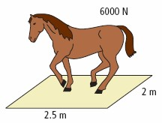
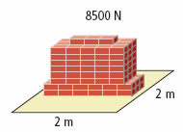
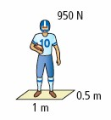

- Rank the three situations from highest to lowest pressure.

- The heaviest object does not have the greatest pressure. Why not?

7.What is the volume of an aquarium with dimensions 3 m × 2 m × l m?

8.Draw a picture of the aquarium in a position that exerts the greatest pressure on a table. Label the drawing with dimensions

9. Draw the same aquarium in a position that exerts the least pressure on a table. Label the drawing with dimensions

10.What is the pressure exerted on the table if the aquarium sits on its side with dimensions
3 m × 1 m? (Hint: The density of water is 1000 kg/m³.)

