Partner Problems
In this activity, you will partner with the person beside you. One partner will face towards the board and one away. The person facing the board must explain the problems on the board in any way they would like, but they cannot write anything down. When the problem is completed, switch.

Packing
Granola bars have a height of 2 cm, a length of 10 cm and a width of 3 cm. If the boxes have a height of 6 cm, a length of 10 cm and a width of 12 cm, how many bars can you fit in a box?

Not all Full
What will be the volume of liquid that will be in pool, shaped as a rectangular prism, with length 20 m, width 15 m and height 3 m, if it is ¾ full?
House
What volume of air would fit in this house?
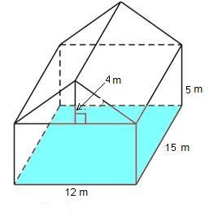
Greenhouse
What is the volume of the greenhouse shown?
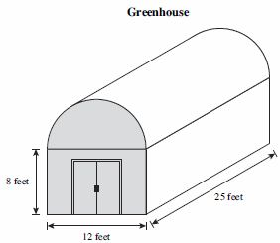
Chocolate Bars
Chocolate bars are 8 cm long, 1.4 cm high and 3 cm wide. What is the volume of a box that will fit 12 bars exactly?

