Day6:
SURFACE AREA OF COMPOSITE FIGURES
Just as finding the area of composite figures can be done, the surface area of composite figures can be calculated. With composite figures that sit on top of one another however, the lateral areas are added but an allowance must be made for the missing surface area between the figures.

Example: Calculate the exposed surface area of the composite figure shown below.

3 cm 2 cm

3 cm 5 cm

Solution:

ASSIGNMENT 9 – SURFACE AREA OF COMPOSITE FIGURES
Calculate the exposed surface area of the following composite figures.

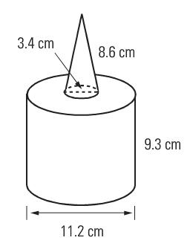
1)

2)

18 cm (diameter)

15 cm

3)
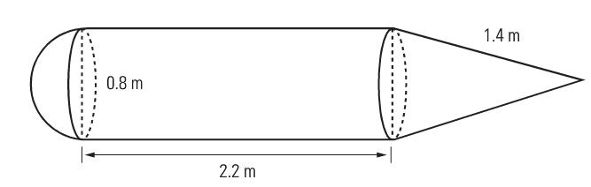

Assignment: Why did Humpty Dumpty have a great fall? And What is cold and comes in cans
Pg 167 #1-6
Quiz next class

