Lab: Reflection and Refraction

Part I: Reflection
Objectives: To determine how rays of light reflect off the surface of a mirror.
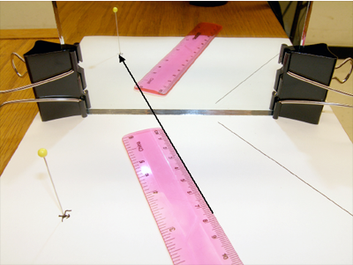
Materials:
- Planar mirror
- Paper
- Pen/pencil
- Ruler
- Protractor

Procedure:
- Take a sheet of any white 8.5”x11 paper – fold it in half then with a ruler, draw a line across the paper on the fold to divide the paper into two equal halves.
- Stand your mirror on the line. You can have one partner hold the mirror. It is important that the mirror does not move or change position during this activity.
- Draw a “+” on the paper in front of the mirror (slightly to one side).
- Get your eye down to the level of the paper on the table and look at the reflection of the + in the mirror. From the position where your eye sees the reflected image in the mirror – take a ruler and draw a line to where the + appears to be in the mirror.
- Draw another line as above – viewing the object in the mirror from a slightly different angle with your eye.
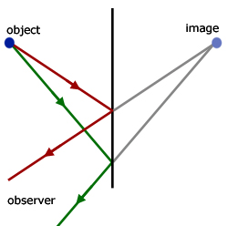
- You should now have two lines drawn from the two positions where your eye viewed the object toward the mirror. These lines represent the rays of light that are reflected from the object – off the mirror – to your eyes. We will now remove the mirror and finish our light ray diagram.
- Set the mirror aside - we now have just the two lines on the paper directed toward the line that divided the paper in half (where the mirror was placed). With a ruler, extend your two lines to the mirror and then continue to extend the lines until the lines meet behind the line of the mirror (as shown here).
Mirror
The lines behind the mirror meet at the position where the image appears to be (behind the mirror). Images that appear behind a mirror are known as virtual images.
- Draw lines from where the reflection bounced off the mirror back to the object you drew on the page.
- Draw normal lines from the mirror.
- Use your protractor to measure the angle of incidence and the angle of reflection and record in the table. What do you notice about these angles?
Θ_{i} | Θ_{r}

Conclusion
Write the law of reflection in your own words:

Part II: Refraction
Objectives: To determine how rays of light refract through a piece of plate glass.

Materials:
- Planar mirror
- Ray Box
- Paper
- Pen/pencil
- Ruler
- Protractor

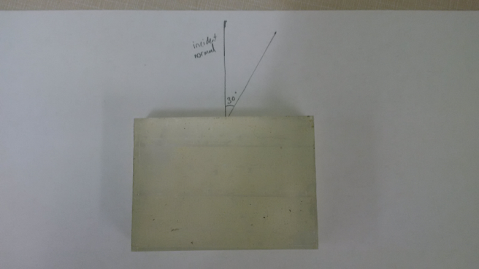
Procedure:
- Place glass on paper and trace around the glass
- Draw a dot in the middle of the long edge of the plate glass
- Draw a normal line to the dot and label as incident normal
- Measure a 30º angle from the incident normal and trace onto graph paper. This angle is Θ_{i}
- Turn on the ray box and line up with your 30º angle. Place a dot where the light emerges from the glass.
- Remove the glass and connect the incident dot with the dot where the light emerges.
- Measure and record the angle as Θ_{r.}
- Repeat with a 45º angle.
Θ_{i} | Θ_{r}
30º
45º

Conclusion
- According to your diagram, are light rays refracted away from or towards the normal as they pass at an angle from an optically less dense medium (air) into an optically more dense medium (glass)?

