**Outline for Math 9 Final**

Similarity (Chapter 4)

* Determine if two objects are similar
* Solve for missing values when objects are similar
* Convert between metric units

Rational Numbers (Chapter 2)

* Order rational numbers
* Add, subtract, multiply and divide rational numbers

Powers and Exponents (Chapter 3)

* Use Exponent laws
* Solve problems involving exponents

Polynomials (Chapter 5 and 7)

* Be able to combine like terms together
* Understand how to use algebra tiles to solve problems
* Multiply and divide binomials and monomials
* FOIL

Linear Relations (Chapter 6)

* Determine the equation for a pattern
* Extrapolate and interpolate from data
* Recognize equations of lines from graphs and graphs from equations of lines

Linear Equations (Chapter 8)

* Be able to solve one, two and multi-step equations
* Solve problems involving linear equations

**<Ch.2 Rational Numbers>**

Rational Numbers: ___________________________________________________________________________

Eg. )_____________________________________________________________________________________

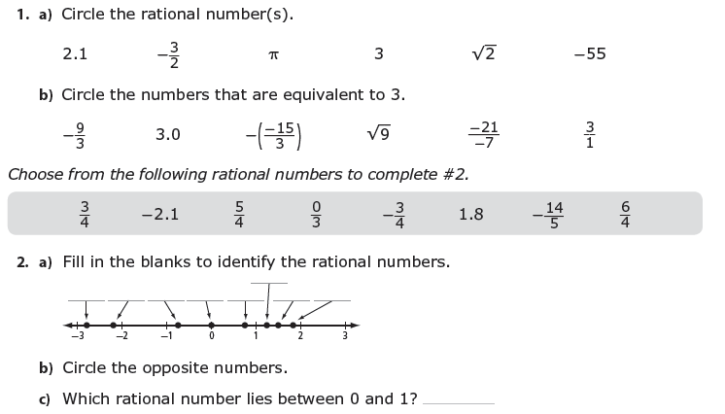

3. 4.

Write the numbers in ascending order. Write the numbers in descending order.

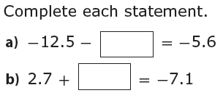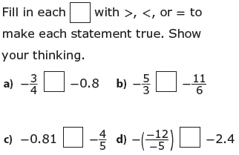

5. 6.

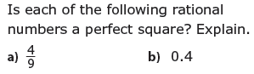

7.



8. Evaluate.



9. Calculate. Show your work.

  

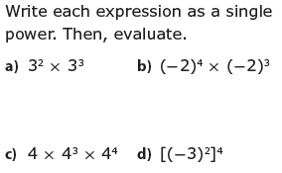**< Ch.3 Exponents & Powers>**

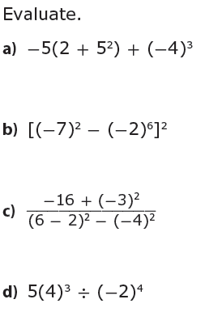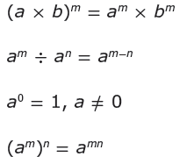

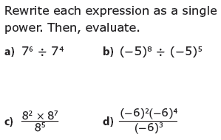

**<Ch.5 Adding & Subtracting Polynomials>**

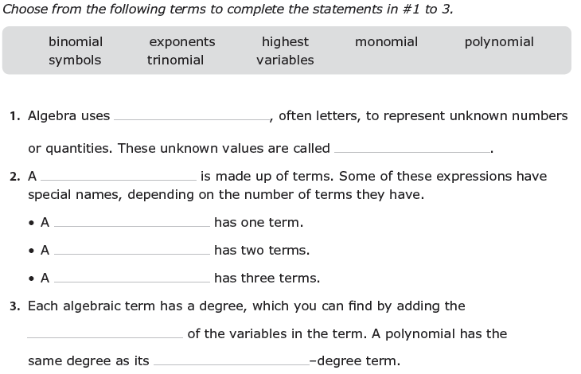

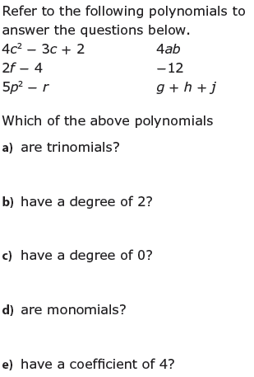

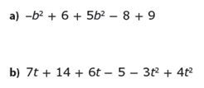Simplify by combining like terms.

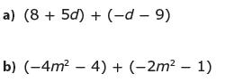 Add or subtract the polynomials.

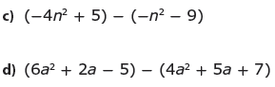

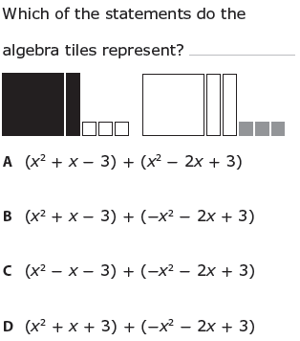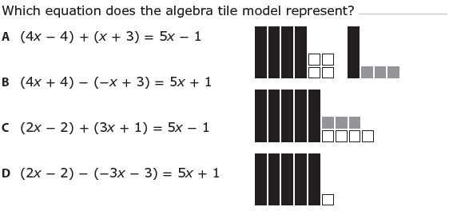

**<Ch.7 Multiplying & Dividing Polynomials>**

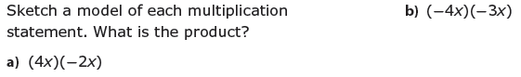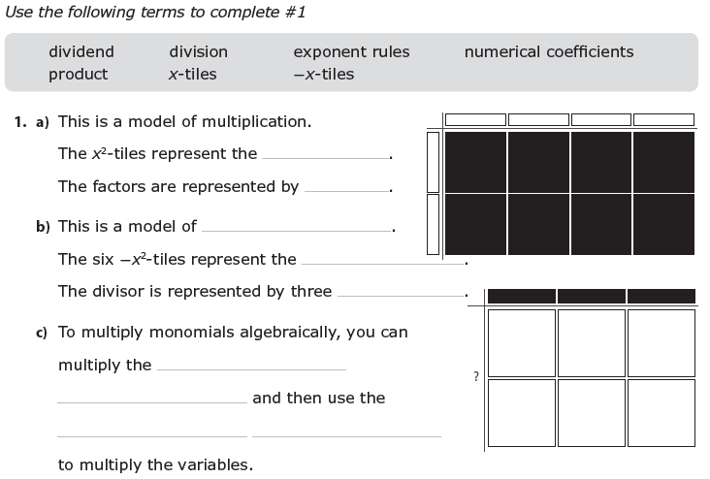

2.

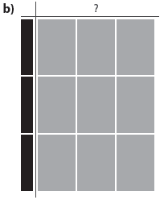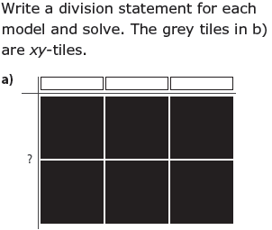3.

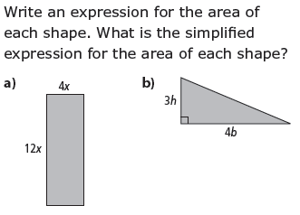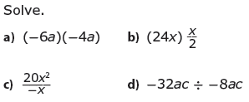

4.

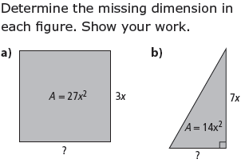

Use the distributive property to expand each expression.

**a)** (5*m*)(2*m* + 3) **b)** (–*n*)(*n* + 1) **c)** (1.3*x*)(2*x* – 5) **d)** (–*m* + 2)(3*m*)

Divide.

**a)**  **b)**  **c)**  **d)** 

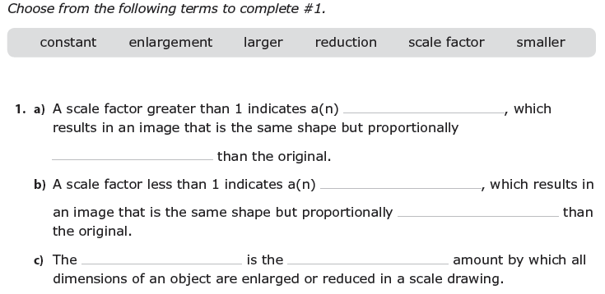

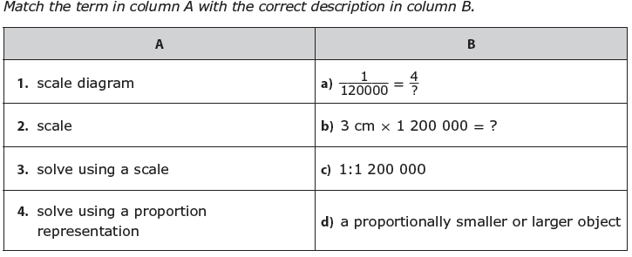

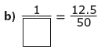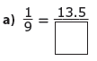Ex) Determine the missing value.

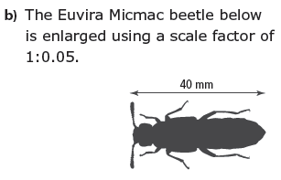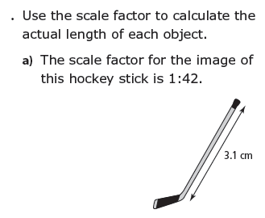Ex)

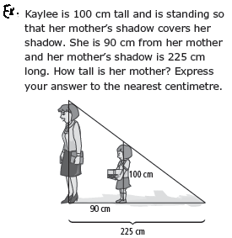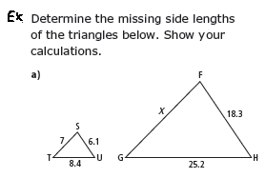

**<Ch.8 Solving Linear Equations>**

**1.** Solve each equation and then show a check of each solution.

**a)** –4*x* = –4.96 **b)**  **c)** 

**d)**  **e) $4c +\frac{2}{3} = -\frac{1}{6}$** **f)** 

**g) $3(m + 0.5) = –2.1$** **h)**  **i) **

**j)** 0.4*x* = 5.58 – 0.2*x* **k)**  l**)** 

**m)** 5(2*x* + 1.2) = 4(*x* – 1.5)

**2.** Solve each problem.

**a)** Carol gave a 15% deposit on a diamond bracelet. The deposit was $73.50. What was the cost of the bracelet?

**b)** Eric earned  of the profits of the canteen on the weekend. His earnings were $620. What was the total profit earned in the canteen?

**c)** The cost of a banquet at Nick’s Catering is $215 plus $27.50 per person. If the total cost of a banquet was $2827.50, how many people were invited?

**3.** Solve each equation.

**a)** *x* + 5 = 12 **b)** 2 = *x* – 9 **c)** 4*x* = –16

**d)** –7.12*x* = 35.6 **e)** –= 25 **f) **= 

**g)** –=  **h)** *x* + 15 = 12 - 3x **i)** 2 + 12x = *x* – 9

**j)**  +5 = –4 **k)** 17 –****= 13 + 

**l)** 3(x – 1) = 5(1 + x) **m)** 2.25 – 1.5x = *x* – 9.75

**n) **=  **o)** –= 