Circuits and schematic diagrams

Open up your circuit kit and try setting up a few circuits. Below draw two different circuits. Each circuit must have at least three components. Draw both the schematic diagram and the circuit diagrams

Circuit 1 | Circuit 2

Create the following circuits. Write down any observations and record any measurements from voltmeters or ammeters
Circuit diagram | 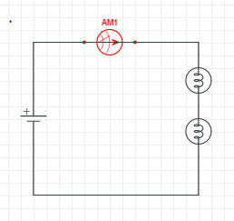 | Circuit diagram | 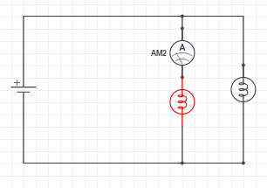
Observations |  | Observations
Current |  | Current
Circuit diagram |  | Circuit diagram
Observations |  | Observations
Voltage |  | Voltage

Circuit diagram |  | Circuit diagram
Observations |  | Observations
Current |  | Current
Circuit diagram |  | Circuit diagram
Observations |  | Observations
Voltage |  | Voltage

