Goal • Show your understanding of the kinds of mirrors used for different purposes.
Identify the type of mirror (plane, convex, or concave) used in each situation below. Write your answer on the line provided.
1. bathroom wall mirror  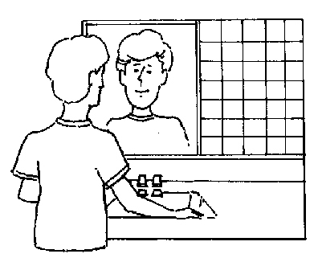  Purpose: to show your exact appearance  Type of mirror: _______________________ | 2. car headlights and flashlights  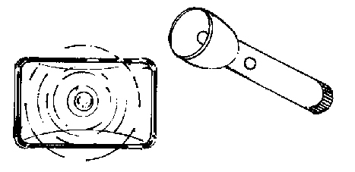  Purpose: to project a strong beam forward  Type of mirror: ________________________
3. store surveillance mirror  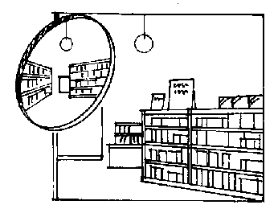  Purpose: to show a wide view  Type of mirror: ________________________ | 4. cosmetic mirror  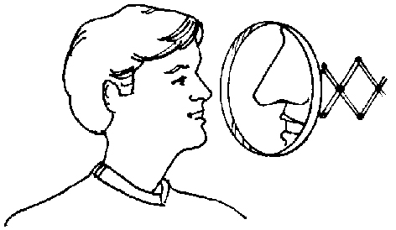  Purpose: to show a magnified view of parts of your face.  Type of mirror: ________________________
5. one-way mirror  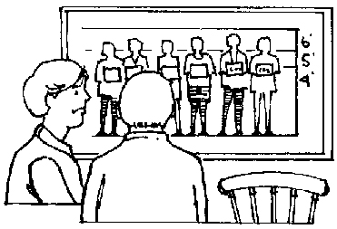  Purpose: to see into a brightly lit room; looks like a mirror to the people being observed  Type of mirror: ________________________ | 6. car mirror  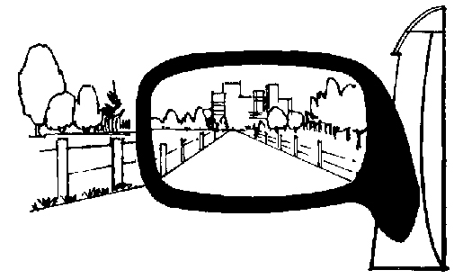  Purpose: to show a wide-angle view behind and beside the car  Type of mirror: ________________________
7. dental mirror  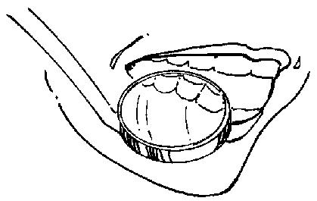  Purpose: to make teeth visible and to  magnify them  Type of mirror: ________________________ | 8. reflecting ball at a dance  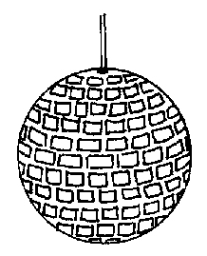  Purpose: to project portions of lights hitting it in many different directions  Type of mirror: ________________________

