NOTES 9.1: Series and Parallel Circuits

Series: One Pathway
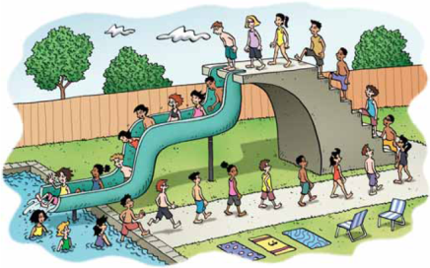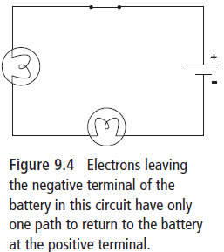
Voltage in Series
- Voltage is the __________________________ difference in __________________________ between two points.
- If electrons________ 12 V from the battery, they will ________all 12 V as they travel from the –ve to the +ve terminal of the battery through the circuit
- Staircase analogy –12 steps up-gain potential energy- 12 steps down lose same energy
- Along the circuit, electrical potential energy is____________________ to other types of energy as it passes through resistors and loads
- In light bulbs this energy is converted to __________________________________.
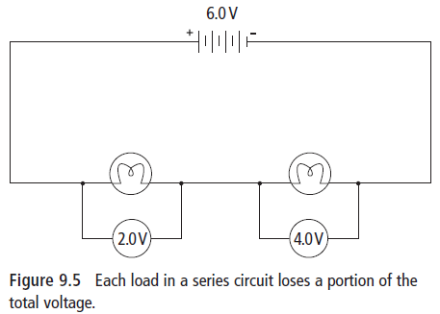

Current in Series
Since electrons _______ each other, they remain evenly spaced out. Within the same pathway, current
______________________________________.
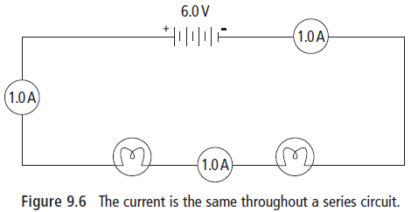
Resistance in Series
There is only _____ pathway. Adding more resistance to the same pathway ______________ the total resistance and _______________ the current in that pathway.
E.g. Adding a dry and sticky portion of a slide after the last one decreases the rate of flow for all the people going down the slide.
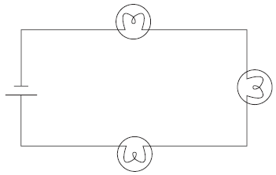
Adding more bulbs _____________ total resistance resulting in total current _____________.
Parallel: Many Pathways
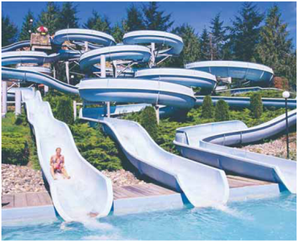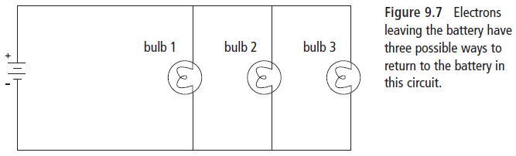
Voltage in Parallel
- Within each ________________, the total voltage gained by the ________________is lost
E.g. there could be many water slides (______________) people can go down, but every person will go down the same height and end up in the same ______________ (positive terminal)
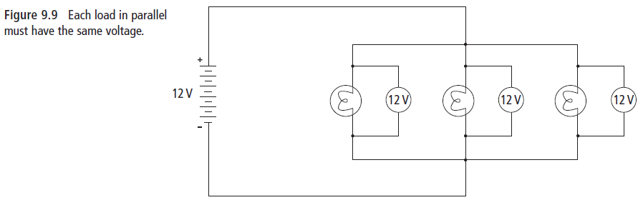
Current in Parallel
The total current will split up at a _________________ point and re-join where the paths meet. More current will flow through paths with ____________ resistance.
E.g. At the top of a waterslide (junction) an attendant makes people go to the next available slide – the slides with the least resistance will have more people going down it every second. 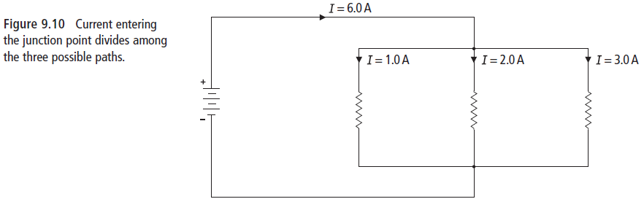
Resistance in Parallel
Any time you create another pathway, you _______________ the total resistance in the circuit. Even if you are adding resistors, adding them in parallel will _______________ the total resistance.
E.g. Adding another waterslide at the water park will increase the flow of people coming down from the top of the slides.

DO THIS!
- Check your understanding 9.1 questions pg. 319 #7-10
- Complete worksheet

