NOTES 8.3: Fluids under pressure
- The atmosphere is a mixture of gases such as ___________________________
- The pressure of the atmosphere is called _____________________
- Atmospheric pressure _____________________ as you move higher in altitude because there are less air particles at higher altitudes
- Air moves naturally from ___________________________________________
- Example. When you drink juice from a straw an area of low pressure is created in your mouth. High pressure air from outside rushes in through the straw carrying liquid with it
- “science never sucks”
- Weather is created by differences in pressure between cold air and warm air
- Warm air is a ________ pressure system
- Cold air is a ________ pressure system
- Cold air moves into areas of warm air creating wind
- If you are underwater, you can feel the pressure of the water all around you. The deeper you go the pressure increases because there is more water above you
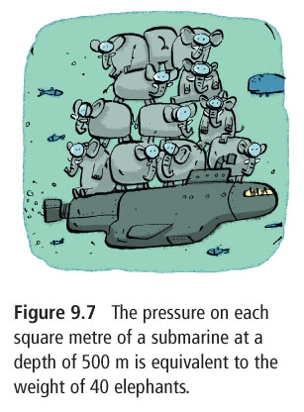
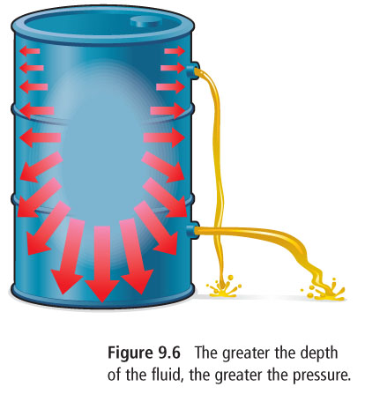

- Buoyancy refers to low density floating on high density

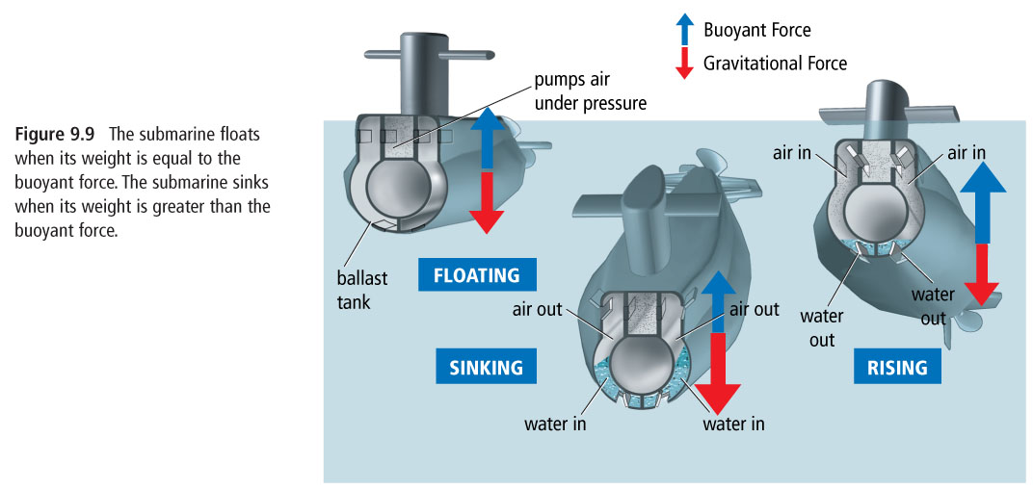
Bill Nye
While watching, answer the following questions
- How much water must an object displace in order to float?

- What do negatively, positively and neutrally buoyant mean?

