NOTES 8.2: Electric Current

What is Current Electricity?
The flow of _______________________________called electrons in a complete circuit.
Electric Circuit (Text page 281)
Electric Circuit: A _______________ pathway that allows ___________ to flow
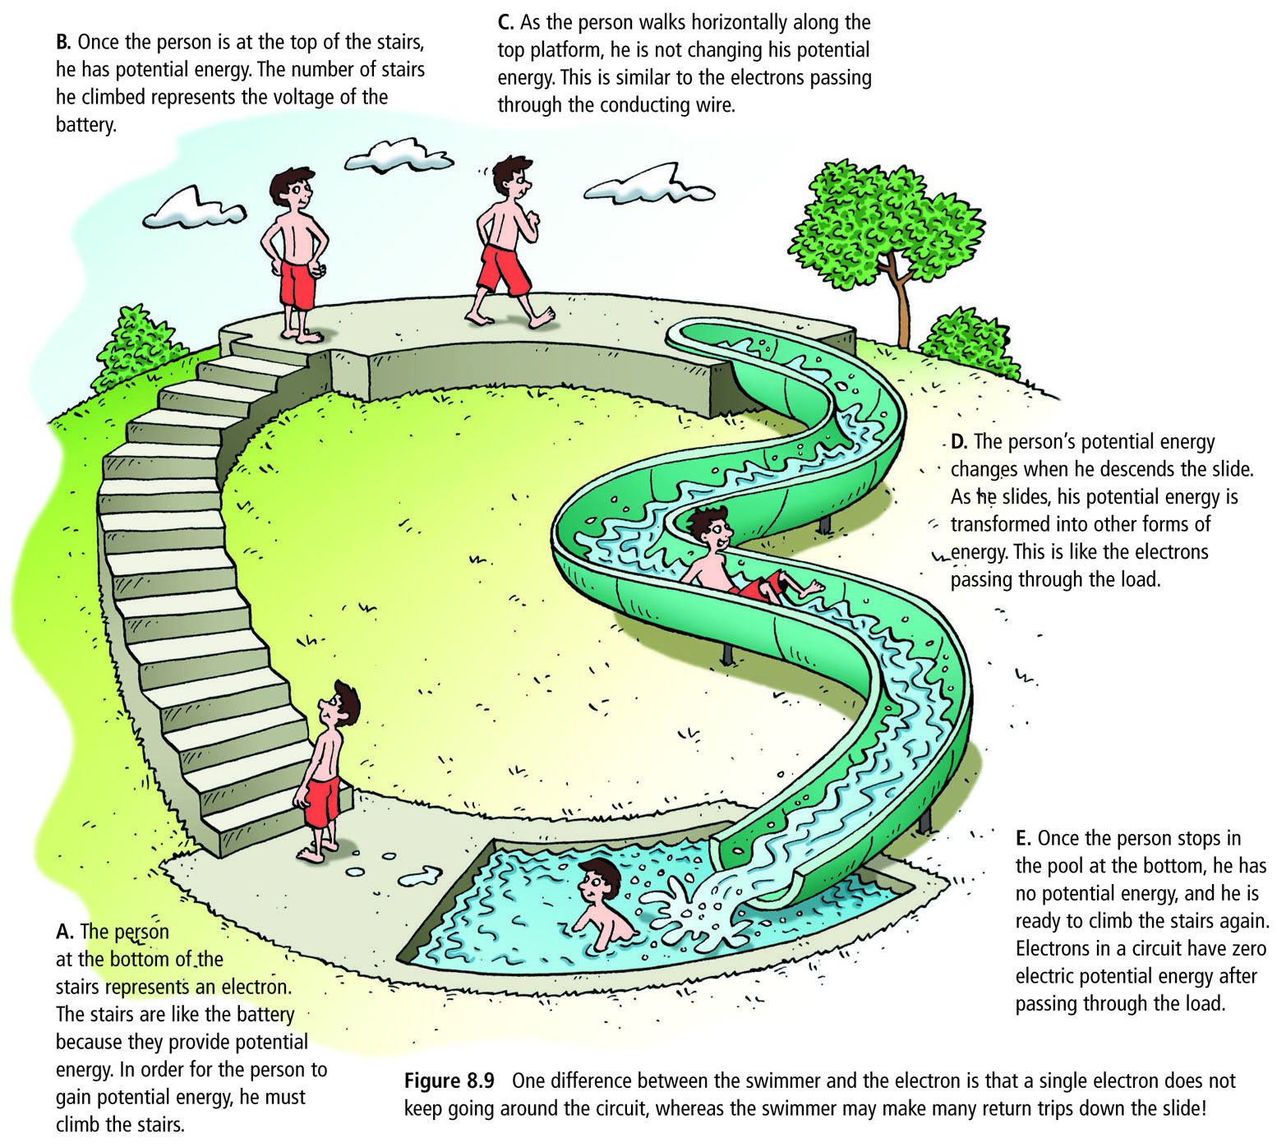
- The person represents an __________________ in a circuit
- Stairs are the battery – the source of potential energy (__________ of stairs is the voltage)
- Potential energy lost only when person slides down – like when electrical energy is ___________ to other forms of energy by a ___________ i.e. light bulb uses electricity to produce light and heat
- At bottom electron/person has _____ potential energy remaining
Four Basic Components in a Circuit
- Source:_______________________________
- Conductor:_____________________________
- Load:___________________________________________________________________
- Switch:__________________________________________________________________
Why does current flow through a circuit?
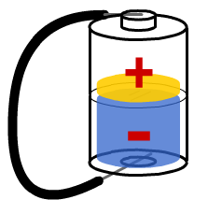
Just like how water would flow from one section of a jar to another until both sides are even, 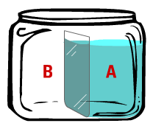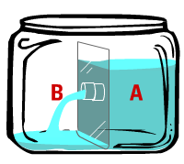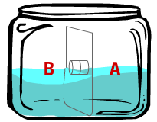
In a battery, electrons will tend to flow from one side (the negative terminal) to the other side (the positive terminal) until both sides are even (neutral).
Circuit Diagrams
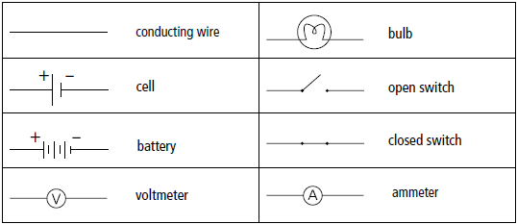
Draw the schematic diagram next to the circuit shown:
- 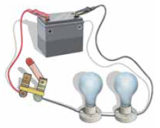

- 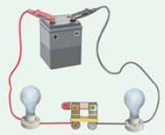

- -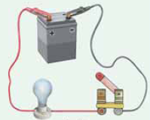

- 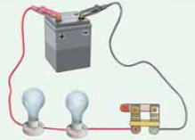 COMPLETE HANDOUT 3-15 NOW!!!!
What is CURRENT?
Electric current is ______________________________________________________________________
The units used for current are:_____________________ Measured using an ______________________.
CONVENTIONAL CURRENT | ELECTRON FLOW
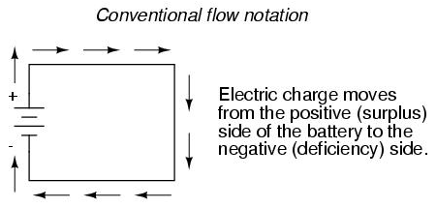 | 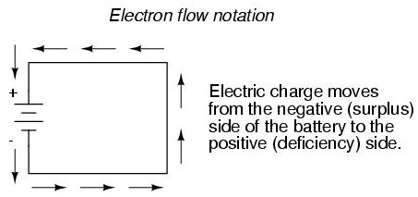
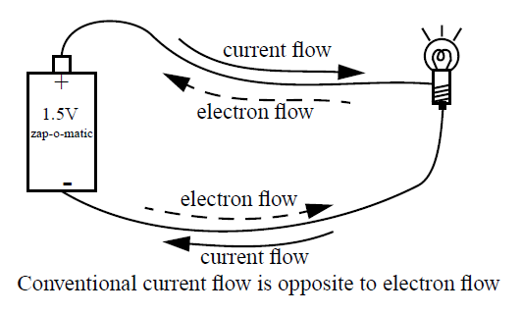
On your own: Draw arrows and labels to indicate the direction of conventional current and electron flow. With your partner: Agree on the correct answers.
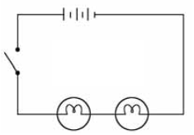 | 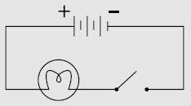
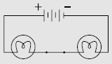 | 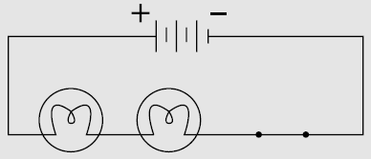

Key Questions:
- What is the difference between potential and kinetic energy?

- What is the difference between static and current electricity?

- What is the difference between conventional current and electron flow?

- Use the charge of electrons to explain why electrons flow from negative to positive.

- What is the definition of electric current?

- What unit is current measured in?

COMPLETE Textbook Pg 289 #1-13

