NOTES 8.1: Electric Potential Energy and Voltage

Electric Potential Energy
Energy:_______________________________________________________
Potential Energy:_______________________________________________
Batteries _____________ electric potential energy.
A battery is defined as one or more __________________ cells connected together.
An __________________ cell converts ______________ energy into
________________ energy.
Electric Potential Difference
Another name for “Electric Potential Difference” is ________________.
______________ is defined as the amount of ____________ _____________ _________ per ______________ of charge.
The unit for ____________ is the volt (V).
An instrument called a ___________________ is used to measure voltage.
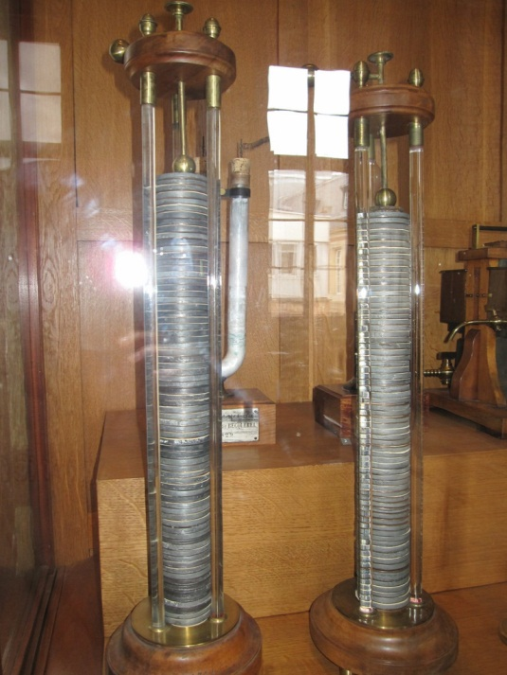
Voltage is named after a man named ________________ ________________ who invented the first modern electric battery (the voltaic pile as shown below).

ANALOGY #1 – Weights and Pie Plates
- What does height represent? ____________________________

- What does amount of mass represent? ______________________________

- What does the amount of sound produced represent? _____________________________

- DEMO #1 (Same masses, different height)
Diagram (draw what you see)

  - When the weights are dropped from different heights, which height generates the louder sound? HIGHER / LOWER (circle one)

  - When electrons travel in a circuit, which voltage allows electrons to release the most energy? HIGHER / LOWER (circle one)

- DEMO #2 (Same height, different masses)
Diagram (draw what you see)

  - When different weights are dropped from the same height, which weight generates the louder sound? HEAVIER / LIGHTER (circle one)

  - When electrons travel in a circuit, which amount of charge allows the most energy to be transferred? LARGER / SMALLER (circle one)
ANALOGY #2 – Man on Stairs
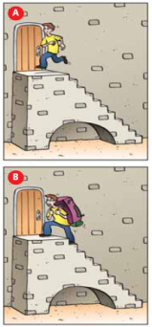 | - Guy in A has built up potential energy  - Guy in B has built up more potential energy because he has done more work by moving more mass (the backpack) to the same height  - Potential difference in battery = ________of the stairs (volts)  - Amount of charge separated in a battery = ______ of the guy (coulombs)

Producing Potential Difference
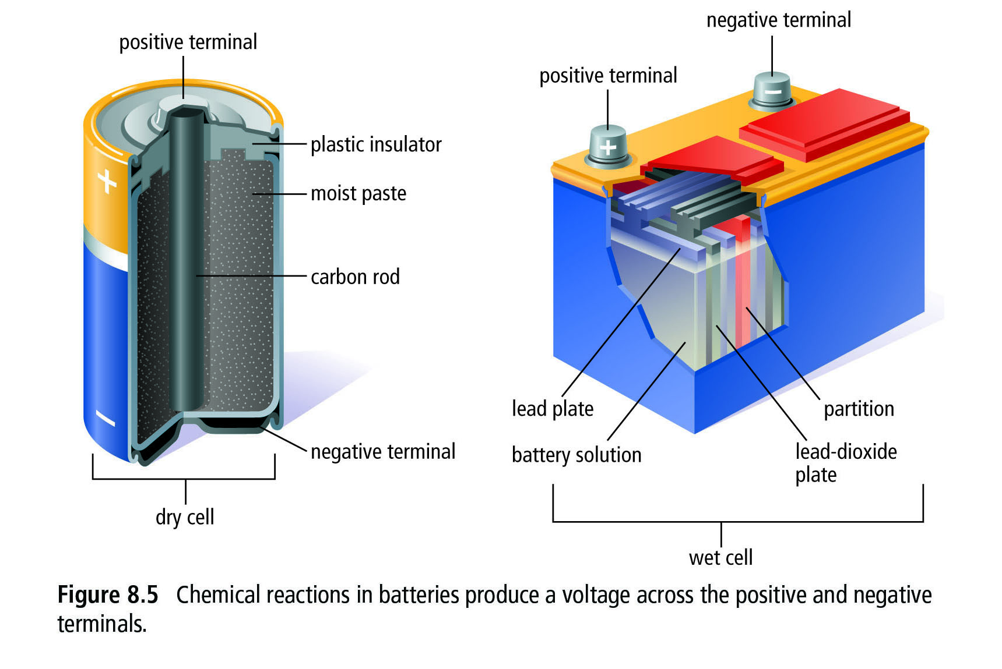
An electrochemical cell works by producing a potential energy difference between the +ve and –ve terminals. Because of this, electrons want to flow from the +ve terminal to the –ve terminal.
There are 2 types of electrochemical cells: _______ cells and _______.

These cells convert _________________ energy into ________________ energy.

How do electrochemical cells produce voltage?
Battery terminals- ________________(usually two different metals) sit in a substance (paste or fluid) called __________________ that conducts electricity.
- Electrolyte pulls atoms off zinc which leave electrons behind on the zinc electrode – allows ____________ charge to build up
- At same time chemical reactions with copper electrode pull electrons off the copper electrode- allows build-up of ____________________
- Electrodes become oppositely charged which results in a potential difference (voltage) between the two electrodes.
- Most electrochemical cells produce ______________
- A 12 V car battery may have eight 1.5 V cells connected together

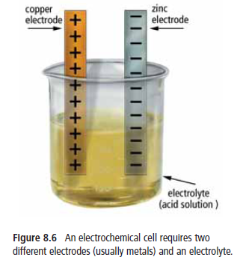

Other Sources of Electrical Energy
What other sources of electrical energy exist other than batteries? Read pg. 274 to find out! Five sources of electrical energy are ________________________________________________
______________________________________________________________________________
____________________________________________________________________________________________________________________________________________________________
Complete Textbook Pg 279 #1-8

