NOTES 6.1/6.2: Chromosome mutations and Karyotypes and Sexual Reproduction

Read pages 194-197. Complete the notes below! Be sure to look at pictures and descriptions! 10 minutes!
Types of Chromosome Mutations
A.____________________________________  B.____________________________________  C.____________________________________  D.____________________________________ | 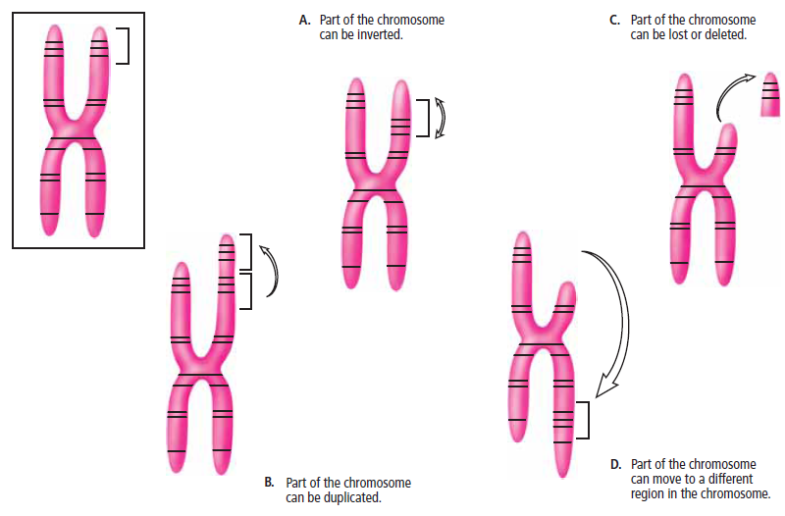
Describe an Example of a Chromosome Mutation in Fruit Flies (figure 6.9)
____________________________________________________________________________________
Refer to figure on the left and text page 195.  E. When do Whole Chromosome mutations occur?  What are whole chromosome mutations? | 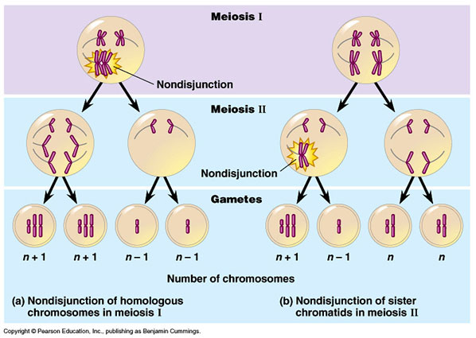

Syndrome: a disease or disorder with a specific group of symptoms that occur together
Example of Whole Chromosome Mutation
- Down Syndrome caused by a whole chromosome mutation where an ____________________________________ chromosome is present in cells. Individuals with this syndrome are shorter, have __________________ facial features, prone to heart defects and diseases such as Alzheimer’s and leukemia.
Unlike gene mutations, chromosome mutations can result in _____________ changes in the organism.
(minor or major)
Because _______ _______ are affected instead of just a few ______________.
Most chromosome mutations _____________passed on to the offspring.
Chromosome mutations usually cause organisms to_____________ before they can reproduce.
Karyotypes - Refer to text page 196.
We can capture what chromosomes look like to discover chromosome mutations by:
- Extracting DNA from cells in ________________________ of mitosis
- Enlarging a picture of the chromosomes from the cell
- Homologous Chromosomes are identified and paired by comparing ___________, ___________________ _______________ and ___________________ ___________________
Read p. 1976-1B Analyzing a Karyotype and write the answers down BELOW
Reply to answers below!
What to Do!
2. Total # of Chromosomes:_________ # of Chromosome pairs:_____________
3. Individual is a____________
What did you find out?
1. Describe chromosome error found:_______________________________________
2. a. Yes or No
b. Why or why not?_____________________________________________________________

What’s Essential:
Mating: ______________________________________________________________________________
_____________________________________________________________________________________
Success after fertilization requires:

External Fertilization
What is it?

PROS  - Less ____________ needed to find mate  - Large number of _______________ | CONS  - Exposure to the outside world  - ___________ do not care for offspring – many offspring do not survive to adulthood

Internal Fertilization
What is it?

PROS  - _____________ develops inside female, protected and ________________  - Offspring raised by parents for _________ or ________ | CONS  - Requires more _____________ to find mate and perform ___________ ___________  - ____________ zygotes produced

Pollen Transport
Purpose: Increase Genetic Diversity
- Move ___________ or ____________ away from parent (as far away as possible)
- Genes spread around rather than remaining near parent
- _____________ (containing ____________) released and carried by __________ to female parts
- _____________ (containing ____________) carried in fruit, eaten by animals and dispersed in feces to form new plants that grow away from parent plants so less competition for food and other resources which increases survival of offspring

HW: Textbook Pg 203 # 5, 7-8,

