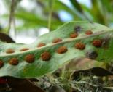**NOTES 5.2: Asexual Reproduction**

1. **Requires only** _______________________**to reproduce!**
2. **All offspring are** ____________________________________________  
   _____________________________________________________________

|  |  |
| --- | --- |
| **Advantages** | **Disadvantages** |
|  |  |

**What type of cells reproduce asexually?**

**What type of organisms reproduce asexually?**

**Types of Asexual Reproduction**

|  |  |  |
| --- | --- | --- |
| **BINARY FISSION** | | |
| * Replication of ________ * Mitosis may occur * Cell divides into _____parts | Eg. _____________,  some bacteria (streptococcus),  dinoflagellates _______ ____________________ |  |

|  |  |  |
| --- | --- | --- |
| **BUDDING** | | |
| * Occurs in some _________ multicellular organisms * Areas of organism undergo ____________ (repeated cell division) * A _____develops that may or may not detach and move somewhere else * The bud ____________ ___________________ | e.g. |  |

|  |  |  |
| --- | --- | --- |
| **FRAGMENTATION** | | |
| * Organism ___________ * Each piece __________  ___________________ | e.g. |  |

|  |  |  |
| --- | --- | --- |
| **SPORE FORMATION** | | |
| * Spores –____________ that can grow into a new individual by _________ * Move with __________or __________ and will grow where it lands if conditions are right * Can develop tough outer coating to survive for years in harsh conditions | e.g. |  |

|  |  |  |
| --- | --- | --- |
| **VEGETATIVE REPRODUCTION** | | |
| * Special cells in plant stems and roots _________________ to form structures that will become identical plants | e.g. | e.g. |

**Vegetative Reproduction and Agriculture**



**Cutting: ____________________________________________________________**

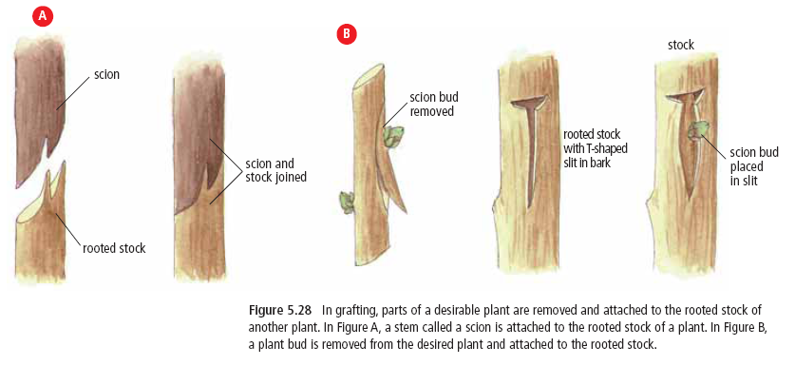

**Grafting: ___________________________________________________________**

**Human-Assisted Cloning**

|  |
| --- |
|  |
| **Reproductive Cloning:** |
|  |
| **Therapeutic Cloning:** |

**Myths**

|  |  |
| --- | --- |
| **Reasons for Cloning** | **Reasons against Cloning** |
|  |  |

***DO THIS!***

* Pg 183 #1-14
* Key Questions!