NOTES 5.1: Ray Model of Light
What is light made of?
- As reviewed earlier the __________ model of light is used to explain some of the behavior of light
  - For example, refraction of light as it enters a new medium
- However, this model is limited. There are cases where this model does not fully explain the behavior of light
  - For example, light bends as it moves near a black hole indicating that it has mass
Models used to explain the behavior of light
- Sir Isaac Newton believed that light is a stream of fast moving tiny particles
- This model is known as the _____________________________________________________
- Parts of this model are still used today
- Einstein also believed that light is composed of small units of mass and energy called _________
- For the study of optics it is helpful to use a simplified model called __________________________________________________________________________
- The ray model of light represents light as a _____________ that shows the ________ that light is travelling
- _______________ are used to analyze the behavior of light (ex reflection and refraction)
- The ray model of light represents light as a straight line that shows the direction the light wave is travelling
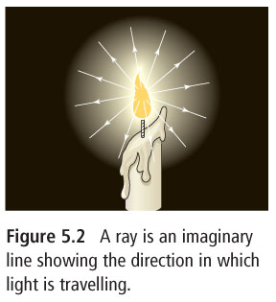

Shadows
- You can use the ray model to predict where _________ will form and how _________ they will be
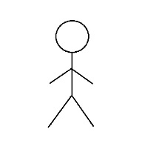

- During sunset and sunrise, your shadow becomes ________ than you are tall
- Closer to noon, your shadow becomes _________ than you are tall
- Ray diagrams can be used to show how the size of shadows is related to the distance of the objects from the source
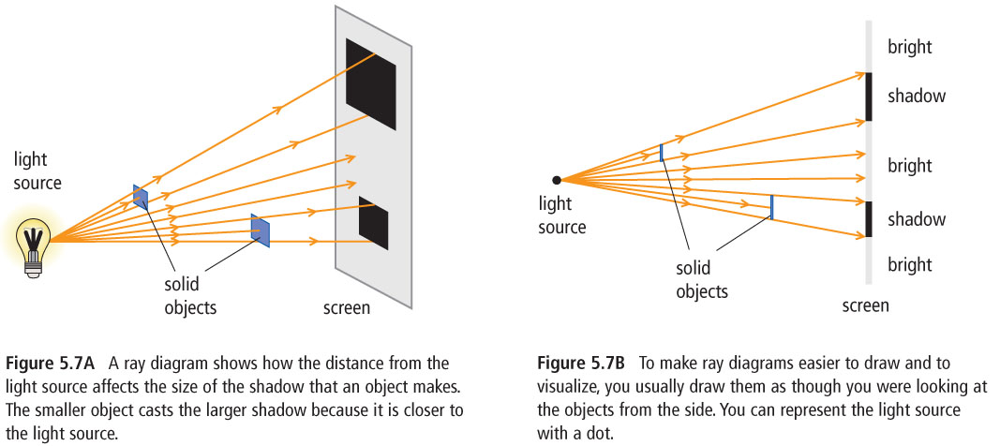
Light and Matter
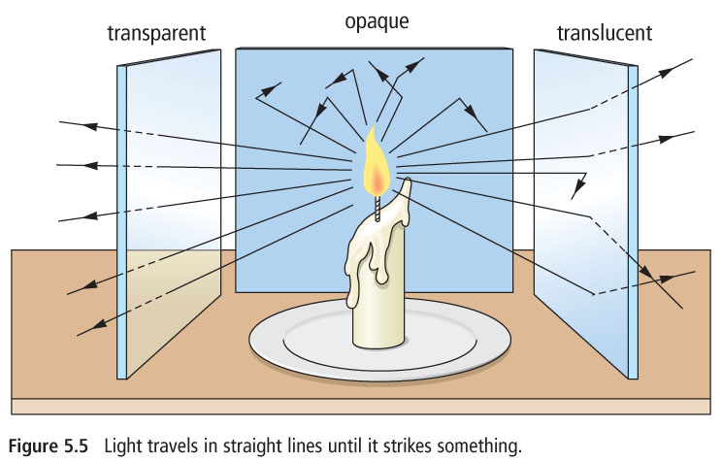
- The type of matter in an object determines the amount of light it absorbs, reflects and transmits
- A ______________________________ material allows light to pass through it. Only a small amount of light is absorbed and reflected
- A __________________________ material such as frosted glass, allows most light rays to get through but scatters them in all directions
- ___________________________ materials prevent any light from passing through

