**NOTES 4.2: Properties of Visible Light**

Visible light is a mixture of all the colours of the rainbow.

**Wave Model of Light**

* In this model, light is a type of wave that travels through empty space and transfers energy from one place to another (Sun to Earth)
* Visible Light is ***one example of a*** wave that you can see.
* **Refraction** – ____________________________________________________________________________________________________________________________________________________________
* If we ______ white light through a prism different wavelengths ________ different amounts
* Longer wavelengths refract _______ than shorter wavelengths

**Isaac Newton and the Visible Spectrum**

* In the 17th century Isaac Newton conducted a famous experiment
* He placed a prism so that a thin beam of light could pass through it
* He saw _________ of color emerge
* He observed that each band of color was ____________________at a different angle

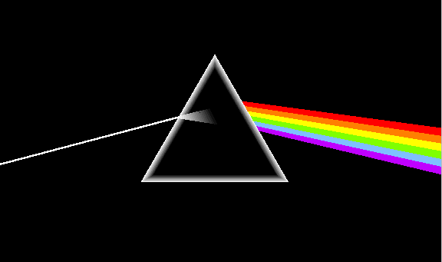

* He then passed the different colors through more prisms to produce white light



**Conclusion**

* Newton concluded that all of the ________ were found in the ________ light and that the prism was not the _______ of the colors
* Each color of light has its own _________ and ___________
* Higher frequency waves bend _______ and the colors ____________
* Example blue bends ___________ than red

**Visible Spectrum of light**

* This demonstration further reinforces the ____________________________________
* In order of **decreasing wavelength** and increasing frequency these colors are

____________________________________________

Abbreviated as _________________________

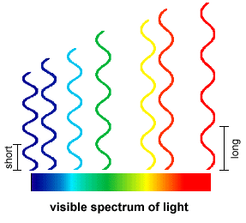

Blue-------------------------------------🡪Red

**Rainbows**

* Rainbows are produced when droplets of water suspended in the air cause light to _________

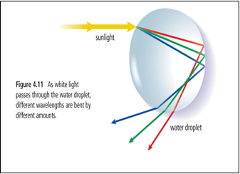

**Primary Colors**

* Only __________, ______________ and _____________are needed to produce all other colors of light
* These colors are known as __________________________ of light
* This is different than the ________________________ of pigment

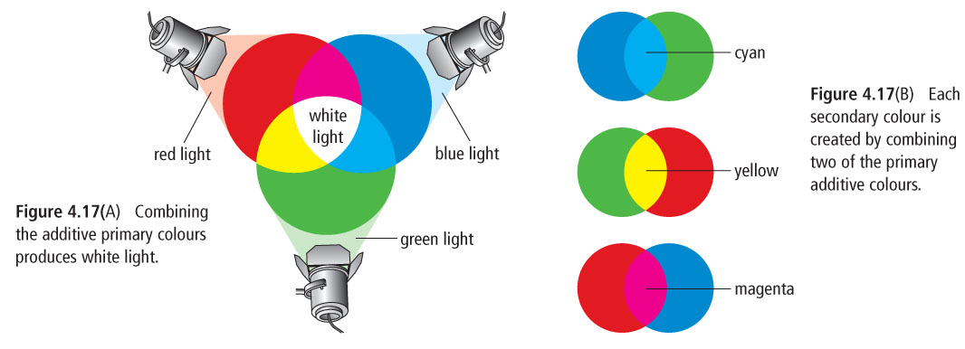

**Colour and Reflection**

* When white light strikes a surface some of the colors can be ________ while others are __________

Example:

* When white light strikes a green shirt all of the colors are _________ **except** green. Green is __________ back to your eye

**Absence of light**

* We cannot see objects in the absence of light because ____________ can be reflected from the object
* Example: a green shirt appears to be black in a dark room
* Since colour is found in light itself, without the presence of light no color can be detected

HW: Pg 151 #2, 3, 4, 6, 8