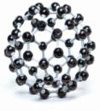
NOTES 3.1: Compounds

What is a compound?

- 2 or more ___________________ joined together to make a pure substance.
- The substance has different _________________________ than the elements that make it up. Ex. Water = H₂O or C₁₂H₂₂O₁₁ (table sugar)

2 Types of Compounds

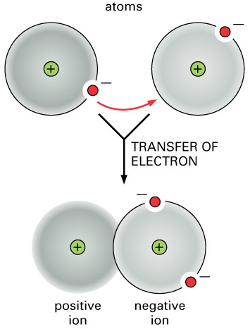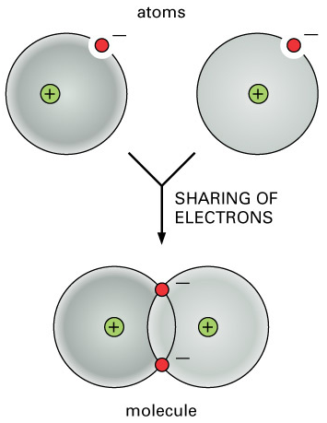
Covalent
Ionic

- Electrons shared between non-metals  - Eg. H₂O (water)  - Form “molecules” a neutral particle made up of atoms joined by covalent bonds  - Bonding due to electron sharing | - Electrons _______________from metal to  non-metal to create oppositely charged ions  - Eg. NaCl (table salt)  - Form “ionic lattice”  - Bonding due to attraction between oppositely charged ions (+/-attraction)

Covalent Compounds (Molecules)

_________________________ atoms _________________ electrons to form _____________________.
Example 1 H₂O  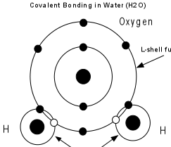 | Example 2 CH₄
 | 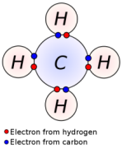
Ionic Compounds

________________________atoms transfer electrons to ____________________________

Create oppositely charged ______________

Positive and negative charges balance each other forming a neutral ___________________________

Example NaCl
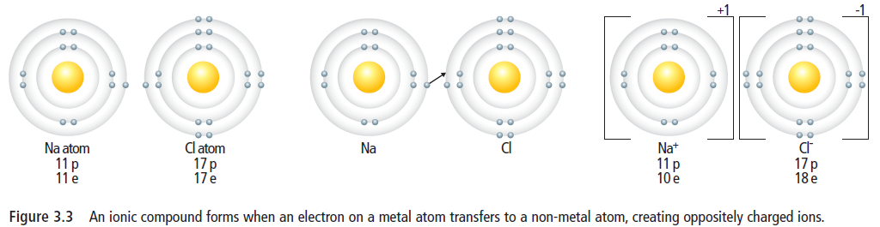

________________ charged Sodium ions are attracted to ___________________ charged Chloride ions
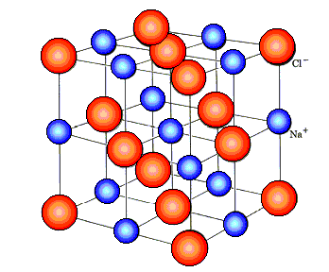
Ions come together to form an ___________ ______________.

All __________ ions attract all __________ ions to form a __________ (eg. grains of salt).

Polyatomic Ions - An ion that is made up of ________________________________ atoms that are held together with _______________________bonds.
Both _____________ and _____________ bonds can sometimes be found in the same _____________.

In potassium dichromate (K₂Cr₂O₇), potassium (K⁺) is ionically bonded to dichromate (Cr₂O₇²⁻),
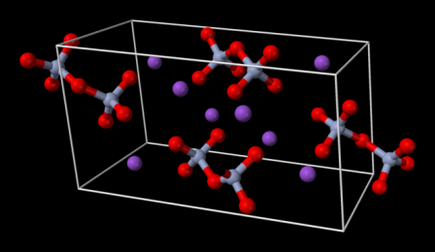
The dichromate ion (Cr₂O₇²⁻) contains 7 oxygen atoms which are covalently bonded to 2 chromium atoms. This 9 atom unit has a charge, so it is called a polyatomic ion.
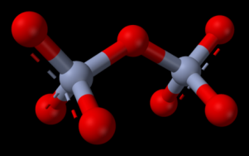
HOMEWORK : Read text pages 76-80 and then complete Textbook Pg 83 #2-9 (Quiz next class!)

