**NOTES 1.3:Diffusion, Osmosis and the Cell Membrane**

**Where we’re going today…**

•

**Diffusion**

**Concentration**

Diffusion says that the area of __________________________________ will move to an

area of _______________ concentration

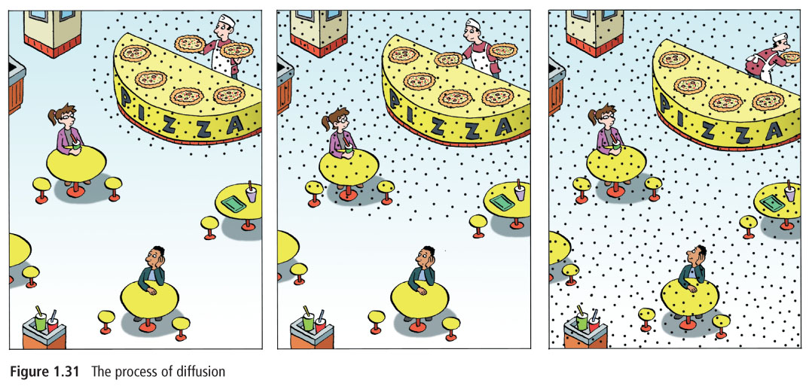

**Diffusion and the Cell Membrane**

The _________________________ allows materials from ________________ the cell to

move _____________ the cell. This occurs through a ____________________________

in the cell membrane.

The cell membrane is called a **_______________________________________________**

because it allows some materials to _________________________ it but keeps ________

_________________ out (eg. coffee filter).

Diffusion is one way materials are ______________________ across the cell membrane.

Particles move across a selectively permeable membrane if there is a ________________

concentration of particles on ____________________________.

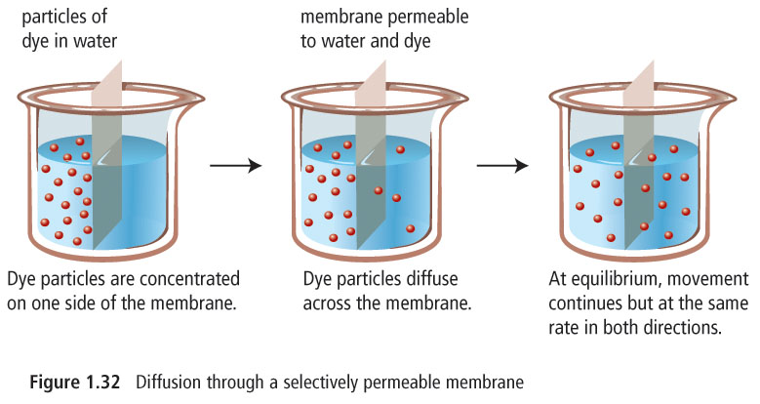

**Equilibrium** –

________________ transferred to your _________________ in your ________________

is an example of diffusion in your body

**Osmosis**

This is the diffusion of __________ particles through a selectively permeable membrane.

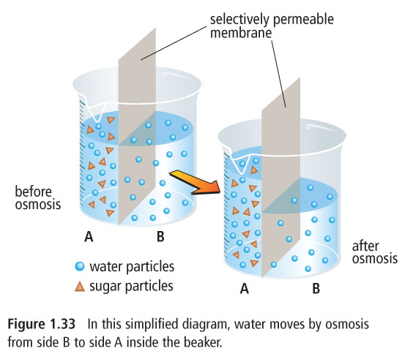

**Water flow through the cell membrane**

To predict the direction of ___________________ through a cell membrane, you have to

_______________ the ___________________________ on both sides of the membrane.

Remember that water will flow from an area of ______________ concentration to an area

of _______________ concentration





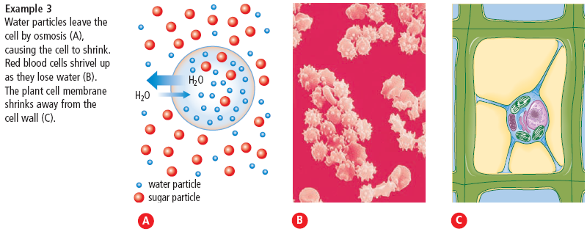

**Application of Osmosis**

_________________ (antibiotic) uses the process of osmosis to destroy harmful bacteria.

Prevents bacteria from ____________________________________________

**Reverse Osmosis**

This occurs when ___________ flows from an area of ______________ concentration to

an area of __________________ concentration across a selectively permeable membrane.

This can happen only when __________________ on the lower concentration side of the

membrane is _______________ causing water to _____________ through the membrane.

This is used to ____________________ water and __________________ it for drinking.