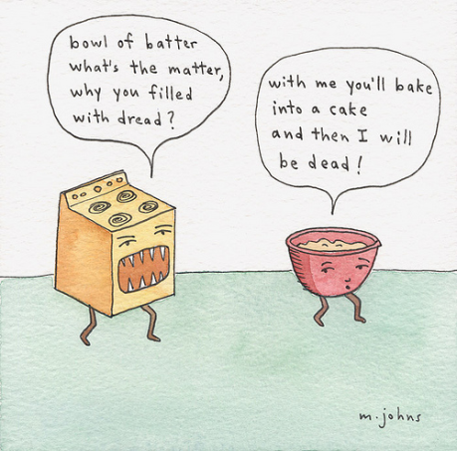
NOTES 1.2: Investigating Matter

Matter is anything that has __________ and __________.
Mass is: __________________________________
Volume is: ________________________________

The Kinetic Molecular Theory (KMT)
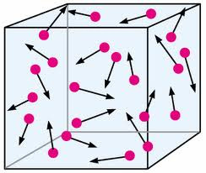
- Matter is made of small particles.

- There are spaces between the particles.

- Particles are always moving.

- _____________________________________________________________

Changes of State

Matter exists in different forms. These are different states of matter.

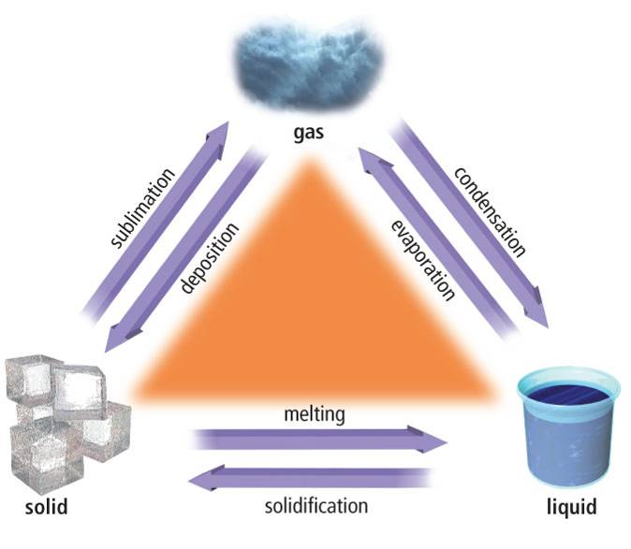

Pure Substances

Matter that is made of the same ___________ and has the same ____________ throughout it.

Element - a pure substance made of one type of atom
- Name 3 elements

Compound - a pure substance composed of at least two elements
- Name 3 compounds

QUESTIONS – Pure (P) or Not Pure (N)?
- Air
- Dirt
- Vinegar
- Sugar
- Soup

DO the BAG OF CHANGE LAB
Making Observations

Qualitative vs. Quantitative Observations Checklist
Qualitative Observations
☐ The observation describes the look and feel of what is happening
☐ The observation does not involve measuring what is being observed
Examples:
- The chemical is smelly and green.
- The object is soft and bright.
- The 60 W bulb was brighter than the 40 W bulb.

Quantitative Observations
☐ The observation describes a measurement made for what is happening
☐ The observation involves measuring what is being observed
Examples:
- 31 grams of the Chemical B was produced.
- The object is has a density of 2.56 g/mL.
- The flight lasted nine minutes.

QUESTIONS – Qualitative (QUAL) or Quantitative (QUANT)?
- The bowling ball is heavier than the basketball.

- The red ball weighs 5 g more than the blue ball.
- The colour changed from blue to green.
- The second bulb was the brightest.

Chemical and Physical Changes Checklist
Chemical Change
☐ A new substance is created – MUST BE CHEMICAL (no need to check others)
☐ The change is not reversible – MUST BE CHEMICAL
☐ There is a change in colour
☐ Gas bubbles are present
☐ Heat, light or smoke are released
☐ There is a change in odour
The more you checked off the above, the more likely the substances you are observing have gone through a CHEMICAL CHANGE.

Physical Change
☐ No new substance was created – MUST BE PHYSICAL (no need to check others)
☐ The change can be reversed – MUST BE PHYSICAL
☐ The substances underwent a change of state (eg. solid, liquid, gas)
☐ The change is ONLY in appearance or form of the material
☐ There is ONLY a change in physical properties like texture, shape, or size
The more you checked off the above, the more likely the substances you are observing have gone through a PHYSICAL CHANGE.
QUESTIONS – Physical or Chemical Change?
- A window is broken when a baseball hits it.

- Water is boiled.
- Bread rises as it is baked in the oven.
- An iron nail rusts as it sits on the ground outside.

